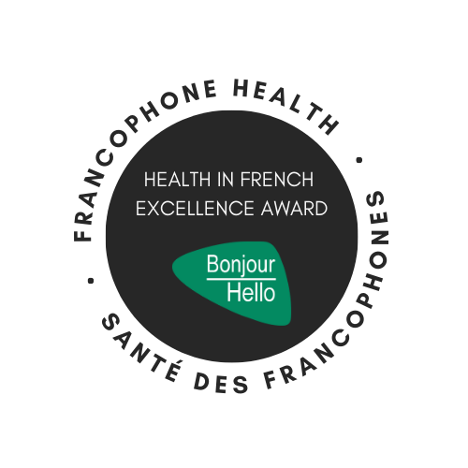

Health in French Excellence Award

The Health in French Excellence Award is presented annually during Les Rendez-vous de la francophonie (RVF) in the month of March. This award stands as a testament to our unwavering commitment to promoting the use of the French language in healthcare and recognizing outstanding contributions from our employees. Les RVF is a series of events organized every year around the world to promote the French language.
As we approach another year, we are excited to embark on our search for the next Health in French Excellence Award recipient, an individual who embodies and has made remarkable efforts in advocating for the French language within the healthcare sector. This award not only celebrates linguistic ability but also underscores the pivotal role of French language in delivering quality healthcare services. Join us as we set out on this journey to honor a deserving champion of French language excellence in healthcare.
We all know a French language champion! They're all around us, working all over the healthcare system, behind the scenes and on the front lines.
Our previous recipients were
2016 - Joyce Plante 2020 - Colette Brodeur
2018 - Jacqueline Daoudi 2022 - Justine Zidona
2024 – Jérémy Baudet
A French language champion may be Anglophone or they may be Francophone. They may be:
- Someone who understands the value of French to our francophone clients/patients/residents and actively promotes its use in the workplace.
- Someone who has worked very hard to learn or improve their French.
- Someone who has supported an employee or a colleague in their efforts to learn French.
- Someone who actively looks for solutions to find services in French for their clients/patients/residents when they can’t offer it themselves.
- Someone who does not speak French, only knows how to say “Bonjour, comment ça va”, but says it to all their francophone clients/patients/residents.
- Someone who is bilingual, working at a non-designated facility, but who takes pride in using their French with their francophone clients/patients/residents.
- Someone who goes the extra mile to follow the French Language Services policies.
- Someone who has managed a complex translation project.
- Someone who gathered up some French books for a francophone patient.
- Your nominee can be anyone who has impressed or inspired you with their commitment to enhancing a francophone’s experience in the health system.
Nominate someone today! It’s fast, it’s easy and it’s meaningful!
Details:
Who can nominate? Any employee working in a program, service, site or funded agency of the Winnipeg Regional Health Authority.
Who can be nominated? Any employee working in a program, service, site or funded agency of the Winnipeg Regional Health Authority. The employee does not have to be bilingual, nor do they have to work at a bilingual program, service, site or funded agency.
How to nominate: Please complete the attached nomination form and provide detailed responses of at least 75 words minimum for each question. Tell us why they should be the next recipient of the Health in French Excellence Award.
Deadline: February 18, 2025
Selection of recipient: A panel of three judges or more will evaluate each nomination to ensure a fair and impartial selection process.
Each nominee will be evaluated based on their contributions to the promotion of the French language in their healthcare setting, their commitment to supporting colleagues, clients, patients or residents in using French, and their overall impact on the workplace's French-friendliness.
Winner Announcement: The Winner and all nominees will be celebrated at a special ceremony the morning of March 10, 2024. The nominator and nominee should save this date.
Questions?: Contact the Francophone Health Team at FLS@wrha.mb.ca.
Send your nomination to: FLS@wrha.mb.ca

Nomination Form

Nominee
Name of nominee: Position:
Does your nominee work in a designated bilingual position?
Name of nominee’s manager:
Name of program, service, site or funded agency:
Work phone number: Work email:
Work address:

Nominator
Name of Nominator: Position:
Name of program/service, establishment or funded organization:
Work phone number: Work email:
Work address:

Explain in a minimum of 75 words for each of the following questions.

1. What has your nominee done to promote services in French?

2. How has your nominee enhanced a Francophone’s experience? (External impact)

3. How has your nominee supported colleagues or employees in their efforts to enhance the services in French? (Internal impact)

4. Please describe how your nominee has gone beyond expectations of their role.

5. Other information you would like to share about your nominee?

My nominee agrees to have their name announced as a nominee/winner and to be celebrated at a small ceremony on March 10th.
Yes No
I declare that to the best of my knowledge the information I have provided is accurate.

Name of nominator

Send your nominations to:
WRHA Francophone Health FLS@wrha.mb.ca
Please indicate in the subject (HEALTH IN FRENCH EXCELLENCE AWARD)

