2025 Long Term Care
Experience Survey

The Winnipeg Regional Health Authority and long term care home operators are collecting feedback from residents and their families and using it to improve care experiences. The survey includes sections to evaluate communication with care staff, food and meal-time services, the home environment, activities and overall satisfaction with the care experience.

https://wrha.mb.ca/ltc-experience-survey/ 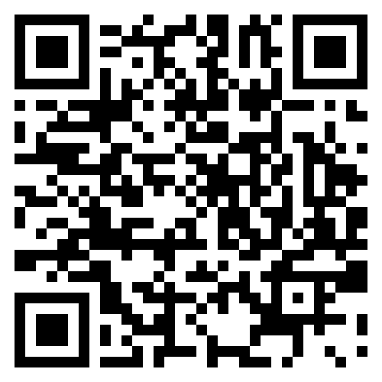

Please note this survey is intended to collect general themes about your personal care home care experience. It is not designed to gather specific complaints regarding the care of a resident. To report specific resident care concerns, please follow the official complaints process for your home.

This survey is filled out anonymously and responses are kept confidential. Your participation is entirely voluntary. By completing the survey, you consent for this information to be shared with the WRHA, the long term care home operator and members of the care team. Please complete it by (Add Date Here).

A reminder, do not disclose personal information (i.e. names, addresses, phone numbers etc.) or personal health information (i.e. illnesses, treatments, medical conditions etc.) that could identify you, whether you are a resident or a family member.

A final report with a summary of findings will be shared with the long term care home operators.

Thank you for sharing your perspective with us. Your feedback on this survey helps us gather valuable information about the programs and services we provide.

If you have questions about this survey, please contact: [insert site contact name, phone number and email].

Sincerely,

[add signature]

