Nutrition & Hydration During COVID-19
This document guides decision-makers on the use of tools to assess nutrition and hydration. There are a variety of processes and tools to choose from to ensure appropriate monitoring, assessment and intervention of nutrition and hydration.
These tools are intended to be used in the event of an outbreak and contain the necessary information to implement intake tracking if all residents are isolated to their rooms.
Please utilize this resource as fits within your site.

REVISED – April 22, 2021

NUTRITION AND COVID-19 RESOURCES
Nutrition status is known to be negatively impacted with COVID-19 infection. Residents infected with COVID-19 will likely have very high calorie, protein, and fluid needs. Please inform your Registered Dietitian of anyone who tests positive for COVID-19.
In the event of an outbreak where residents are isolated to their rooms:
Nursing or Registered Dietitian Responsibilities:
- Place “Encourage Food and Fluids” (Appendix A) poster on each resident door/ dining room (for those residents who need to eat in the dining room).
  - Ensure it is filled out correctly using the care plan/kardex

- Select “Resident Meal Intake” form (see Appendix B) form. Note that this package includes 4 forms which provide similar information in a different format. Each site may find a specific tool works best within their site. These forms may be modified further depending of site preferences. Place in designated area for each resident (ex: on door):
  - Once tool is selected, ensure there are enough forms printed for all residents.
  - Depending on the detail within the intake recording document, utilize other tools for accurate recording, such as your site Input/Output tool, as required to increase accuracy of recording.
  - Provide guidance to staff recording intake:
    - WHOEVER removes the resident tray from the room after meals is responsible for filling out the % consumed (Health Care Aide (HCA), Family, Other staff, etc). Additional guidelines may include requesting that the person recording intake circle or highlight the entry if intake is less than 75%, for ease of review.
    - See “A Guide for All Resident’s Intake Reference Sheet” (Appendix C) for information on how to assess % consumed.
    - Provide guidelines for HCA communication of inadequate intake. For example, if using Appendix B:3 or Appendix B:4 “Alert Nursing and/or Dietitian if resident consumes less than 75% of provided food or beverages for three consecutive meals.” Or “Talk to the registered dietitian if the resident eats 50% or less of 2 out of 3 meals per day for three days in a row.”
    - Offer fluid frequently throughout the day.

- Establish time frame for routine review of intake forms, such as daily for nursing, and time frame to be established for registered dietitian.
- Select other tools (Appendix D):
  - Dehydration Risk Assessment Tool: this tool may be used in its current format or modified. It may be used as a checklist as a reminder for parameters that increase dehydration risk.
  - Gastrointestinal Distress Treatment Options - Oral Rehydration Solutions to Enhance Fluid Intake

- Educate HCAs on tips to enhance intake and signs and symptoms of dehydration utilizing tools (Appendix E) such as:
  - Improve nutrition and hydration in residents during COVID-19 in 5 STEPS.
  - Malnutrition and Dehydration: Know the Risks and Take Action
  - Dehydration Fact or Fiction
- Use Long Term Care Nutrition and Hydration Guidelines (draft) for more information on providing care during outbreak, including review of:
  - roles of team members
  - outbreak section re: practice (e.g. physically distanced mealtimes) and team roles
  - tips to enhance intake
Health Care Aide or Other Team Member Responsibilities:
Fill in “Resident Meal Intake” form when resident is finished their meal following site guidelines and using the “Monitoring Intake Poster” and other site tools as required.

Potential Post COVID-19 Symptoms
- Re-emergence of typical COVID-19 symptoms or new appearance of COVID-19 symptoms in residents who were asymptomatic throughout their quarantine
- Compromised respiratory function with reduced tolerance, new restrictive lung disease
- Compromised cardiac function from new cardiac injury
- Compromised physical function including decreased mobility, loss of range of movement, fatigue, pain
- Thromboembolic events including PE and CVA
- Hypotension
- New onset of dysphagia
- Persisting loss of smell, decreased appetite & thirst
- Persisting diarrhea
- Hypoglycemia even in residents without a diagnosis of diabetes, hyperglycemia in those with diabetes even if insulin/oral medication doses have been stable
- Changes to cognition, delirium (including hypoactive delirium), worsening cognitive impairment
- New or worsening anxiety or depression
- Persisting dizziness and headache

Highlighted items: those with nutritional implications.

Shared with permission from Kathleen Klaasen, CNO, Deer Lodge Centre

Appendix
Appendix A: Encourage Food and Fluids Poster
Appendix B: Resident Meal Intake Forms
- Resident Meal Intake by Unit
- Detailed Resident Meal Intake by Unit – Including Nourishments
- Individual Resident Meal Intake
- Detailed Individual Resident Meal Intake – Including Nourishments
Appendix C: Monitoring Intake – Poster Guide
Appendix D: 2 minute script for educating staff on intake recording
Appendix E:
- Dehydration Risk Assessment Tool
- Gastrointestinal Distress Treatment Options - Oral Rehydration Solutions to Enhance Fluid Intake
Appendix F:
- Improve nutrition and hydration in residents during COVID-19 in 5 STEPS.
- Malnutrition and Dehydration: Know the Risks and Take Action
- Dehydration Fact or Fiction

NAME:
Please Encourage Food and Fluids
Offer small amounts frequently
Alert nurse if resident not eating or drinking enough

DIET ORDER: _________________________________
Mildly Thick/Nectar Thick Level 2 Fluids
Moderately Thick/Honey Thick Level 3 Fluids
Fluid Restriction
Milk allergy
Lactose intolerance
FLUID PREFERENCES:
WATER (Circle: ICE/ COOL/ ROOM TEMP)
MILK
JUICE (Favorite Flavors: ________________)
SUGAR-FREE JUICE
OTHER _____________________________

REFER TO ADL SHEET/CARE PLAN FOR ADDITIONAL INFORMATION
MEAL INTAKE
Please mark intake as 0, 25, 50, 75 or 100%, and pertinent observations.
Circle entry if intake is 50% or less.
Date: _________________________
Room#/  Resident | Breakfast |  | Lunch |  | Supper
 | Food | Liquid | Food | Liquid | Food | Liquid

DETAILED MEAL INTAKE
Meals – mark % food consumed, and estimate fluid consumed (in mL)
Snacks – mark amount of food consumed (e.g. ½ sandwich), and estimate fluid consumed (in mL)
Date:___________________________
Resident/  Room # | Breakfast |  | Lunch |  | PM Snack |  | Supper |  | HS Snack
 | Food | Liquid | Food | Liquid | Food | Liquid | Food | Liquid | Food | Liquid

MEAL INTAKE
Please mark intake as 0, 25, 50, 75 or 100%, and pertinent observations.
Circle entry if intake is 50% or less.
Resident Name/Room: _________________________
Week of:  ____________ | Breakfast |  | Lunch |  | Supper
 | Food | Liquid | Food | Liquid | Food | Liquid
Monday

Tuesday

Wednesday

Thursday

Friday

Saturday

Sunday

DETAILED RESIDENT INTAKE
Please mark in % for each meal and snack and pertinent observations. Circle entry if intake at meal is 50% or less.
Resident Name/Room: _________________________
Week of:  ____________ | Breakfast |  | Lunch |  | PM Snack |  | Supper |  | HS Snack
 | Food | Liquid | Food | Liquid | Food | Liquid | Food | Liquid | Food | Liquid
Monday

Tuesday

Wednesday

Thursday

Friday

Saturday

Sunday

A Guide for ALL Residents’ Intake How much did they eat? (Food Intake)
100% | 75% | 50% | 25% | 0%
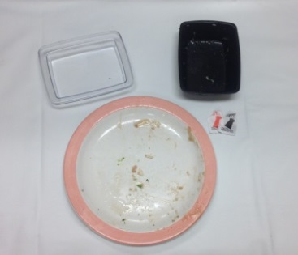 | 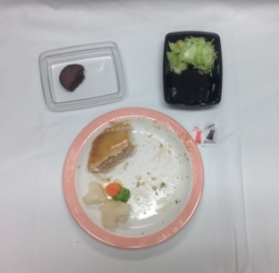 | 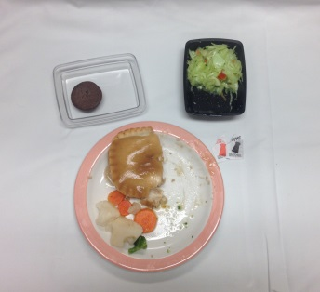 | 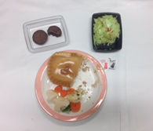 | 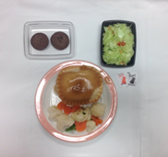
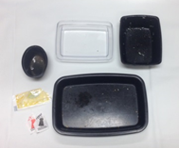 | 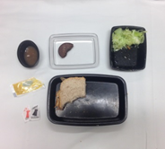 | 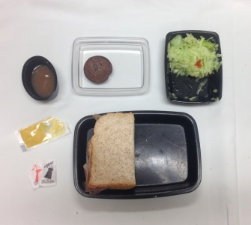 | 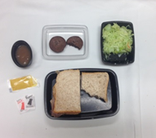 | 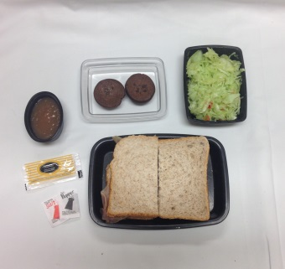

How much did they drink? (Fluid Intake)
100% | 75% | 50% | 25% | 0%
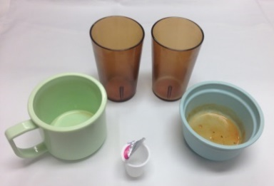 | 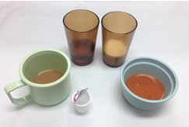 | 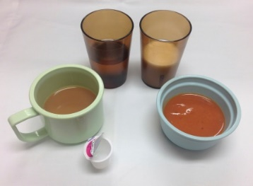 | 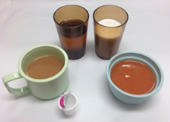 | 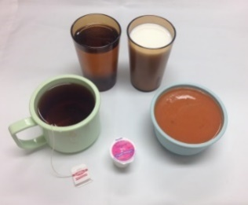

2 minute Huddle Script for HCAs: Meal Intake Recording
Across the region there is an increased awareness on the risk of malnutrition and dehydration in long term care, particularly in the context of positive COVID-19 cases. Physical distancing and isolation at meals times can increase someone’s risk of malnutrition. With this in mind, we wanted to highlight a monitoring tool that may be used to keep close track of intake of food and fluid at meals and snacks.

This poster is used as a guide for recording intake. We need to refer to the poster to accurately record percent eaten at any one meal. Do not rely on “usual” intake to reflect intake at the current meal (ie. if they eat half of what they normally do, this should not be recorded as 50%; what should be recorded is the % of the total meal eaten at that meal). To record fluid intake, we will be using volumes rather than percentages.
This detailed intake form is new. With consistent recording of meals and snacks, we can track if a resident is eating or drinking less and determine if a change in care plan is needed. You can see that there is space to record intake of food and liquids at each meal and snack, as well as an opportunity to record any intake that occurs on the night shift. At meals, the % of the total meal is to be recorded, with help from the poster from the previous slide, as needed. At snacks, it would be noted whether a snack was consumed by marking either an x, if no snack was consumed, or a check mark, if one was. For recording all fluids throughout the day, mark the amount in millilitres in the appropriate space. You can refer to the input/output working sheet to help in recording volumes.

This new recording form is to be used after each meal.
- Recording intake directly after each meal may assist in more accurate recording rather than waiting until the afternoon or evening to do all the recording for the day.
How else can I help?
- Offer more food and liquids.
- Use NFS communication form to request more food and/or liquids as needed.

Remember:
Accurate recording and offering food and liquid are key to helping our older adults stay healthy. We all need to work together to provide the best care.

Addressograph

Dehydration Risk Assessment Tool

This is a tool to help identify individuals at risk for dehydration. Shaded items are particularly associated with dehydration. Add comments as appropriate.

A Care Plan for Dehydration Risk should be completed for any individual with 2 or more ‘YES’ responses, and fax to the Dietitian.

Risk Factors | YES |  | NO | Comments:
Physiological signs
Inadequate Fluid Intake/Fluid Restricted Diet
Diuretic Therapy (i.e. furosemide)
Meds (laxative, NSAIDS, anti-psychotics, steroids, etc.)
Acute Disease (fever, infection, vomiting)
Constipation/Diarrhea
Swallowing Problems (e.g. on or needs thick fluids)
Not drinking between meals
Dry/Sticky Mouth &/or Tongue
Complaints of Headaches &/or Dizziness
Dry and Brittle Hair
Clinical Signs
Hx of unintended weight loss (weekly weights)
Recent or history of UTI
Tube Feeding/Enteral Nutrition
Skin Turgor (dry or inelastic skin)
Terminal illness
Uncontrolled Diabetes Mellitus (HgbA1C >8.5%)
Decreased kidney function (Urea, Creatinine)
Concentrated Urine
Functional Signs
Functional Impairment (hand dexterity, blindness)
Cognitive Impairment/Increased Confusion
Urinary Incontinence/Urinating a small amount
Impaired decision making
Unaware of need to drink/Decreased Thirst
Increased Fatigue or Tiredness (sleeping more)
Dependent for eating and drinking
Physical mobility - wandering
Unable to make needs known
Completed by: __________________________ Date:_____________ Faxed to RD
(Signature)

Gastrointestinal Distress Treatment Options
Oral Rehydration Solutions to Enhance Hydration

Definitions:

Dehydration: A complex condition resulting in a reduction in total body water. This can be due primarily to a water deficit (water loss dehydration) or a salt and water deficit (salt loss dehydration) as a result of inadequate intake or vomiting or diarrhea.
Oral Rehydration Solutions (ORS): are aqueous solutions composed of glucose and electrolytes, including sodium, potassium, chloride, magnesium, and phosphorus, with dehydration preventative and rehydration activities. Upon oral administration of the oral rehydration solution (ORS), water, electrolytes and glucose are absorbed from the gastrointestinal (GI) tract into systemic circulation. This replenishes the body's supply of water, carbohydrates and electrolytes, and prevents both dehydration and renal dysfunction. ORS is available through pharmacy as a powder or in ready to use format. Flavoured ORS can increase palatability.
Rehydration: The process of restoring lost water (dehydration) to the body tissues and fluids. Rehydration is imperative whenever dehydration occurs, from diarrhea, vomiting, lack of drinking, or medication use. While rehydration can be by the oral route, subcutaneous route (hypodermoclysis) or the intravenous (IV) route, this guideline focuses on the oral route.

Rehydration Failure: Progression of resident specific signs of dehydration, failure to replace deficit over 8 hours, or the presence of intractable vomiting and severe diarrhea.

Objective:
1. To treat dehydrated residents using an oral rehydration solution to reduce severity/frequency of vomiting and diarrhea. This may be used as:
- the sole therapy
- or as complimentary therapy with IV or hypodermoclysis when more timely repletion required.
2. To determine when ORS is required versus simple encouragement of fluid intake
3. To reduce future issues related to dehydration, such as orthostatic hypotension associated falls, arrhythmia associated electrolyte abnormalities, acute kidney injury or skin breakdown.
In cases of dehydration due to inadequate intake, specialized ORS may not be required.

Goal: To replace fluid losses of 1000 mL over 4 to 6 hours to reduce:
- morbidity
- need for IV/hypodermoclysis
- Emergency Department visits for IV or care related to advancing dehydration.

Procedure:
- Consult Phase: Consult prescriber regarding resident’s condition before proceeding with an oral rehydration solution (ORS), including goals of care, medication review, contraindications. If medications are to be given for nausea or pain wait 20 minutes after medications to begin drinking ORS. It is highly recommended that residents not consume food or nutritional supplements during ORS therapy but can resume eating once symptoms are resolved.
- Initiation Phase:
- Use containers where total volume is known. If able, use bottles or glasses that have volume measures on the side to assess volume consumed.
- Serve ORS at temperature preferred by resident, do not dilute or add ice. Provide resident with a straw, if able to use safely. Thicken fluids to appropriate consistency if necessary.
- Instruct the resident or help the resident as needed to drink 30mL every 5-10 minutes (consider using a 30mL medication cup if required for measurement). Use a clock if available as it’s important that it is given slowly at first.
- Log fluid volume consumed and record episodes of vomiting and diarrhea.

- Progression Phase: Consumption Recommendations Modified for PCH

ORS Solution | Total Treatment Time if ~30mL consumed at 5 to 10 minute Intervals
1st 250mL consumed | 40 minutes to 1 hour 20 minutes
2nd 250mL consumed | 1 hour 20 minutes – 2 hours 40 minutes
3rd 250mL consumed | 2 hours – 4 hours
4th 250mL consumed | 2 hours 40 minutes – 5 hours

- Residents with vomiting should be encouraged to maintain a slower rate of intake until they tolerate the fluid well. A small amount of vomiting is not an indication to stop oral rehydration.
- If the first 250mL has been taken without vomiting and nausea is controlled, increase to 60mL every 5-10 minutes. Residents without vomiting may drink faster as tolerated.
- If symptoms have resolved after 1000 mL of ORS consumed can resume intake of preferred fluids and/or food as tolerated by resident.
- If rehydration failure occurs consult prescriber.

- If resident refuses or is unable to consume ORS reassessment and consider alternate means of hydration such as IV therapy or hypodermoclysis.
- Preferred solution is commercially produced ORS available from pharmacy. However when there is unavailability of commercial ORS or resident refusal, if there is capacity within the site, alternative options such as homemade ORS recipes are options:

Base Beverage: Water | 1 litre water  ½ teaspoon table salt  6 level teaspoons sugar  Options: If resident dislikes the taste of plain solution, add artificially sweetened drink crystals until acceptable.
Base Beverage: Tomato Juice |  | 625mL plain tomato juice  375mL water
Base Beverage: Orange Juice | 360mL unsweetened orange juice  600mL water  ½ teaspoon table salt
Base Beverage: Gatorade® G2 |  | 1 litre Gatorade® G2  ½ teaspoon table salt

References
Patiño, A. M., Marsh, R. H., Nilles, E. J., Baugh, C. W., Rouhani, S. A., & Kayden, S. (2018). Facing the shortage of IV fluids—a hospital-based oral rehydration strategy. New England Journal of Medicine, 378(16), 1475-1477.
Pickering, L. K., & Shane, A. L. (2012). Oral Rehydration Therapy. Retrieved September 24, 2020, from https://www.sciencedirect.com/topics/medicine-and-dentistry/oral-rehydration-therapy
Rehydration Project. (2019, August 23). Oral Rehydration Therapy. Retrieved September 24, 2020, from https://rehydrate.org/ors/ort.htm

ORS Intake Recording Form – Sample

Time | Consumption (mL) | Symptoms
 |  | Vomiting | Diarrhea
0720
0730
0740
0750
0800
0810
0820
0830
0840
0850
0900
0910
0920
0930
0940
0950
1000
1010
1020
1030
1040
1050
1100
1110
1120
1130
1140
1150
1200
1210
1220
1230
1240
1250
1300
1310
1320
1330
1340
1350
1400
1410
1420
1430
1440
1450
1500
1510

Time | Consumption (mL) | Symptoms
 |  | Vomiting | Diarrhea
1520
1530
1540
1550
1600
1610
1620
1630
1640
1650
1700
1710
1720
1730
1740
1750
1800
1810
1820
1830
1840
1850
1900
1910
1920
1930
1940
1950
2000
2010
2020
2030
2040
2050
2100
2110
2120
2130
2140
2150
2200
2210
2220
2230
2240
2250
2300
2310

Time | Consumption (mL) | Symptoms
 |  | Vomiting | Diarrhea
2320
2330
2340
2350
0000
0010
0020
0030
0040
0050
0100
0110
0120
0130
0140
0150
0200
0210
0220
0230
0240
0250
0300
0310
0320
0330
0340
0350
0400
0410
0420
0430
0440
0450
0500
0510
0520
0530
0540
0550
0600
0610
0620
0630
0640
0650
0700
0710

There are many risks that residents in Long Term Care face that could cause malnutrition or dehydration. Some things to watch are:

- Vomiting, diarrhea, or fever can cause low appetite, and fluid losses.
- Texture modified diets; residents that need texture changes in food or drinks may not eat or drink as much.
- Meds to watch out for: water pills (such as furosemide), laxatives, anti-inflammatories (such as ibuprofen), steroids, and antipsychotics.
- Hot weather and rooms can cause fluid losses.
- High resident activity, such as pacing, may result in fluid loss and increased food needs.
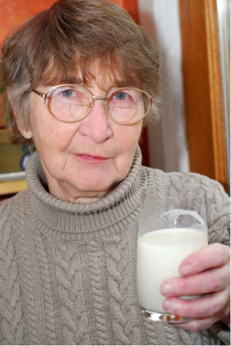

TAKING ACTION
REPORT Signs and Symptoms of malnutrition and dehydration to the Nurse/Registered Dietitian
• • •
Signs and symptoms of Dehydration include:
- Dry/sticky mouth &/or tongue
- Complaints of headaches &/or dizziness, feeling tired
- Dry skin and brittle or dry hair
- Recent UTIs, or having UTIs often
Signs and symptoms of Malnutrition include:
- Weight loss,
- Fatigue
- Poor appetite or poor intake
- Frequent colds or infections
- Feeling cold
- Changes in mood/ depression

Malnutrition and Dehydration: Know the Risks and Take Action

Here are some strategies and tips to help prevent, detect, and treat malnutrition and dehydration.
- Know your resident! Identify and report resident’s spoken and non-spoken cues signaling discomfort (e.g. moans/groans, and facial expressions that aren’t normal for the person).
- Notice changes to a resident’s eating and drinking habits, and tell nursing staff.

- Encourage eating and drinking fluids throughout the day, both during and in between meals, by reminding residents to have a drink or a few bites.
- Helping with mealtimes and encouraging food and drinks is important for the elderly population. Getting rid of barriers (e.g. cutting food), cueing, and helping with meals and snacks will go a long way in making sure everyone is well fed.
- If a resident needs assistive devices, encourage and help as needed.
- Make sure residents have drinks and snacks on hand that they enjoy.
Eating and drinking small amounts throughout the day is easier than more food at one time.
- When needed, record the amount of food or drinks a resident finishes. If you notice someone eating less than normal, or less than half their entrée, let nursing know.
- 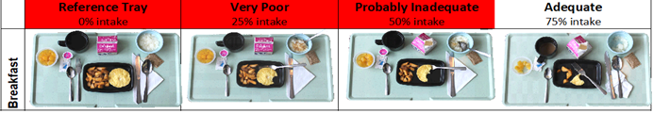Make sure you weigh each resident regularly as per their care plan.

Dehydration:
OFFER fluids that residents prefer even though they may not be as hydrating as others
• • •
PROVIDE fluids between meals as well as at meals for optimal hydration
• • •
NOTICE the warning signs:
- Inadequate fluid intake
- Dry/sticky mouth or tongue
- Complaints of headaches, dizziness, &/or feeling tired
- Dry/brittle hair or skin
- Unaware of need to drink, decreased thirst, or dependent for feeding
- Recent UTIs, or having UTIs often
- Constipation/ Diarrhea

or

60% of the human body is water. We need water for healthy skin and joints, to digest food, regulate body temperature and help the brain function.
The first sign of dehydration in the elderly is thirst. As we age we lose the ability to feel thirsty, so be aware of other symptoms of dehydration in the elderly.
Fluids and electrolytes can be lost with vomiting, diarrhea and fever (sweating). Severe fluid losses may require medical attention.
Residents who enjoy fluid other than water are at a greater risk for dehydration. All fluids are hydrating to some degree so even those who do not drink water can stay hydrated if offered fluids they enjoy.
Dehydration may cause dry skin, dizziness, constipation and even headaches.
Fluids are the only way to hydrate the body. Watermelon, gelatin desserts, popsicles, and applesauce are also great for hydrating.
Milk may maintain hydration better than water. Studies show that the nutrients in milk help fluids stay in the body longer than water.
Residents who enjoy caffeinated beverages are at a greater risk for dehydration. Caffeine can increase the need to urinate, but that does not mean it will increase the risk for dehydration!

Quick Hydration:  - Chocolate Milk  - Milk  - Orange Juice  Hydrating:  - Juice (fruit/vegetable)  - Tea  - Water  It’s a Liquid:  - Coffee | Other Options:  - Applesauce  - Ice Cream  - Popsicles  - Soup  - Jell-o  - Fruit (fresh/canned)  - Cucumbers/Tomatoes  - Ginger ale/7-up  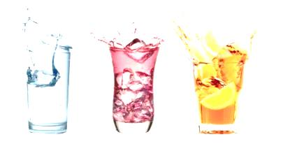  - Ice cubes

Ask residents: “what can I get you to drink?” instead of “would you like a drink?”

Have all staff offer sips of fluids when walking by or visiting residents using fluids available at bedside

Offer refills of favorite fluids during meals

Keep note of those needing assistance, sit with the resident and offer fluids more often

Ensure the environment encourages the desire to eat and drink.

