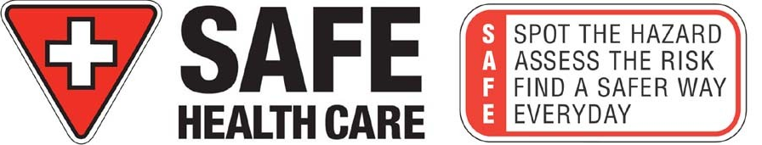


OCCUPATIONAL AND ENVIRONMENTAL SAFETY & HEALTH (OESH)

NOTE: The following information is required to ensure your safety and welfare at work

CONFIDENTIAL PERSONAL, WORK AND HEALTH QUESTIONNAIRE

PERSONAL INFORMATION  Surname:  Given Name:  Previous Surname:  Date of Birth (D/M/Y):  Address:  City/Postal Code:  Home PH:  Other PH (Cell):  E-mail: | WORK INFORMATION  Employee No.:  Office Location:  Program/Dept.:  Job Title/Position:  Work Phone #1:  Work Phone #2:  Supervisor:  Supervisor’s Phone:  Date of Hire:
Manitoba Health # (6 Digit): PHIN # (9 digit):

1. List all known allergies:
2. Do you have any physical or emotional health needs that may impact on your ability to do the job you’ve been hired for?

3. Do you have a history of dermatitis, eczema or any other skin problems?  Yes  No
4. What City and Country were you born in?
5. If born outside of Canada when did you emigrate to Canada?
6. Is there anything about your health that you would like to discuss?

I hereby authorize the WRHA Occupational and Environmental Safety & Health to administer tests as outlined in the WRHA Immunization Policy.

Employee’s Signature Date (D/M/Y)

Occupational Health Nurse Signature Date (D/M/Y)

Occupational Health Units of
WRHA Occupational and Environmental Safety & Health (OESH)

WRHA Occupational Health Units provide service between
8:00 a.m. and 4 p.m. Monday to Friday. Please confirm times with individual sites.

Concordia Hospital
1095 Concordia Avenue
Winnipeg, MB R2K 3S8
Occupational Health: (204) 661-7289
Appointment Bookings: (204) 661-7434
Confidential Fax: (204) 661-7317

Corporate / Community Health Services
Occupational Health: (204) 926-8060
Appointment Bookings: (204) 926-8060
Confidential Fax: (204) 944-8417

Deer Lodge Centre
2109 Portage Avenue
Winnipeg, MB R3J 0L3
Occupational Health: (204) 831-2122
Appointment Bookings: (204) 831-2153
Confidential Fax: (204) 831-2918

Grace Hospital
508 - 408 Booth Drive
Winnipeg, MB R3J 3R7
Occupational Health: (204) 837-0869
Appointment Bookings: (204) 837-0869
Confidential Fax: (204) 943-0237

Health Sciences Centre
NA618 – 700 McDermot Avenue
Winnipeg, MB R3E 0T2
Occupational Health: (204) 787-3312
Appointment Bookings: (204) 787-3312
Confidential Fax: (204) 787-1172

Seven Oaks General Hospital
2300 McPhillips Street
Winnipeg, MB R2V 3M3
Occupational Health: (204) 632-3280
Appointment Bookings: (204) 632-3280
Confidential Fax: (204) 694-0479

Victoria General Hospital
2340 Pembina Highway
Winnipeg, MB R3T 2E8
Occupational Health: (204) 477-3322
Appointment Bookings: (204) 477-3107
Confidential Fax: (204) 477-3449

Please submit this form to your home site:
- Breast Health Centre to Corporate/Community OESH
- Community Health Services (this includes: Home Care, Palliative Care, Mental Health, Public Health) to Corporate/Community OESH
- Laundry submit to Seven Oaks OESH
- RDF submit to Concordia OESH
- River Park Gardens submit to Deer Lodge Centre OESH
- Tissue Bank to Corporate/Community OESH

