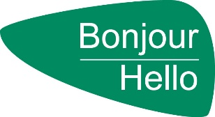
WRHA French Language Services
Rosetta Stone License User Request and Agreement

Please email your request to fls@wrha.mb.ca
Name: Position:
Work Address: Phone Number:
Do you work in a designated bilingual position/facility or program? Yes No
If yes please specify:
Are you under condition of employment? Yes No
Work Email Address: Home Email Address:
Agreement starting: Agreement Ending:
The WRHA French Language Services Rosetta Stone online language-learning program is intended for professional French language skills growth and development.
I understand that:
- Highest priority will be given to employees who work in designated bilingual positions, facilities or those on condition of employment.

- By accepting this opportunity, I am making a commitment to the WRHA French Language Services department to spend at least 30 minutes per day (x20days) equaling 10 hours per month.

- Lending periods are 3 months and can be renewed pending progress and availability. Licences can be revoked at anytime by the WRHA FLS staff if usage isn’t sufficient.

- Users may withdraw from the program at any time. Access to a learner license at a later date is dependent upon availability.
The WRHA French Language Services department has access to a limited number of licenses for a limited time. The French Language Service Coordinator and the Administrative Assistant are the program administrators and monitor user progress. Information regarding a learner’s usage and progress may be shared with managers upon request. French Language Services reserve the right to revoke learner licenses when necessary to optimize usage of the program.

I, have read and understood the above user agreement.
Date:

