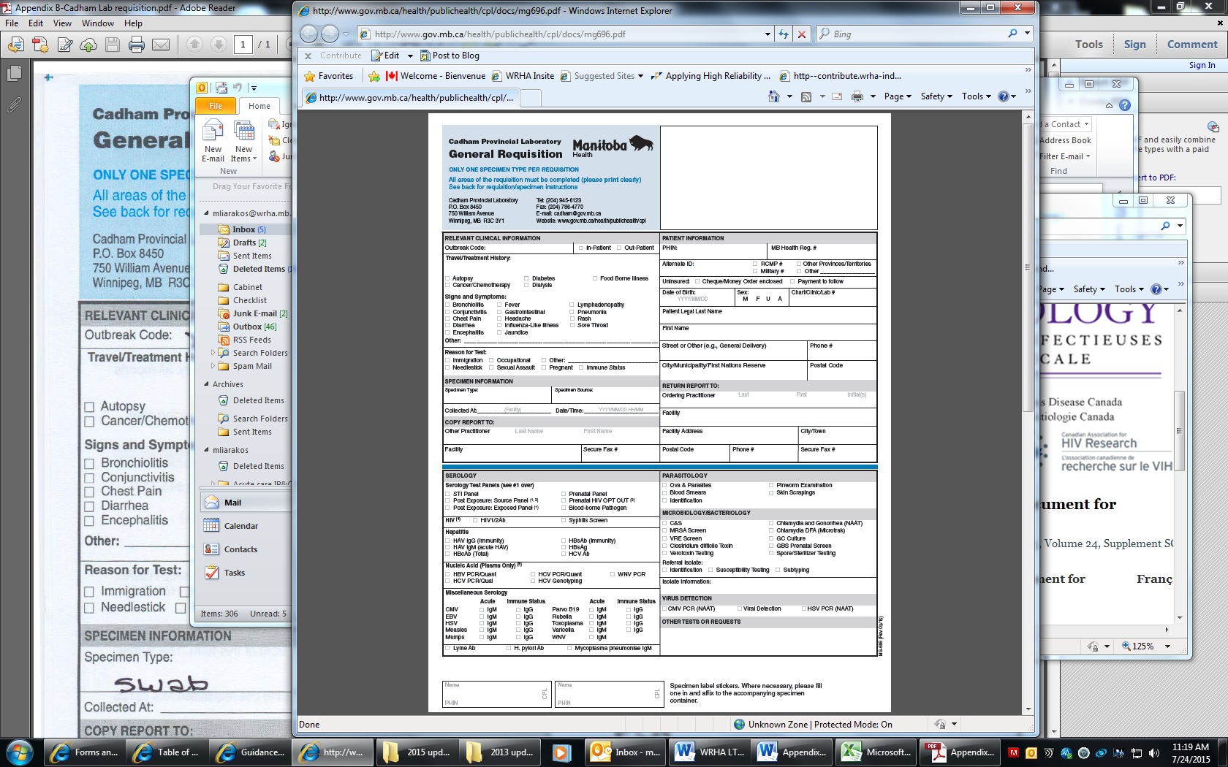
Χ
Χ

Appendix F
Medical Director’s name here
Stamp resident addressograph or affix label here
Site name here
CD coordinator name here
Your assigned facility number
940-2690
Site address
Winnipeg

Flocked Swab
NP

TWO Identifiers required
Affix one label to VTM bottle housing specimen and one to the specimen bag
TWO Identifiers required

Fill in the highlighted areas

