Designed by Colleen Rempel
Dietetic Intern, WRHA
Education Tool
This script and corresponding visuals can be used to educate staff about the upcoming IDDSI changes within the WRHA.
IDDSI Implementation - Phase 1
Education Tool: 5 Minute Huddle

IDDSI Implementation – Phase 1

Five Minute Huddle: Script

WHAT is IDDSI?
- The WRHA (Winnipeg Regional Health Authority) Feeding & Swallowing Expert Review Group has identified and accepted the International Dysphagia Diet Standardisation Initiative (IDDSI) as best practice.
- As a result, Nutrition & Food Services is reviewing and updating our diet compendium, including diet texture and thick liquid diets.
- In 2019, we are starting with Phase 1 of ISSDI Implementation, with terminology changes to the thick liquid diets.
- In 2020, Phase 2 implementation will impact terminology and types of food texture diets.
- We will follow the IDDSI Framework, which includes new names, colours and numbers to identify the different diets. (See Poster 1). At a minimum, diet name and number will be identifiers within WRHA.

WHO does IDDSI impact?
- Across the WRHA, we are changing diet texture and thick liquid names to match international standards (IDDSI).
WHY is IDDSI important?
- This is important for PATIENT SAFETY across all ages, care settings and cultures.
- Terminology becomes consistent in all care settings, with all practitioners.
- Example: In Canada, a 88 year old patient named Eldon on the wrong diet type choked on partially chewed food and died.
- When somebody is placed on a texture or consistency modified diet, it may be for client preference, however usually these diets are required for client safety! Among other things, texture and consistency modified diets may help reduce the risk of choking, food or liquid going into the airway, ease chewing, and improve quality of life surrounding meals.

WHEN is IDDSI being Implemented?
- Transition to new terminology for diet orders and client care plans will begin May 1, 2019.
- By the end of July 2019, it is anticipated that all care plans will be updated.

HOW will IDDSI be Implemented?
- During transition, we will start using dual labels including BOTH the current and new terminology. (See Posters 2 & 4).
- Dual Terminology will be used for up to 8 months, depending on the site.
- Transition to only IDDSI terminology for thick liquid consistency is expected by the end of 2019.

ADDITIONAL NOTES:
- We have created an implementation package to help you make the transition.
- Depending on the sector and site you work at, changes needed will be different.
- Education is extremely important so that all staff are aware of the changes.

Poster 1: IDDSI Framework – WRHA Implementation Phases

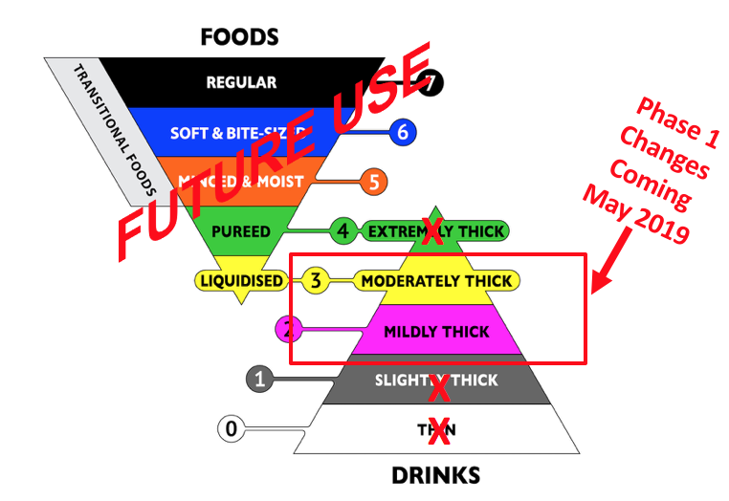
Photo Credit: The International Dysphagia Diet Standardisation Initiative 2016 @https://iddsi.org/framework/

Poster 2: New/Current IDDSI Diet Terminology
New Thick Liquid Diets

IDDSI (International Dysphagia Diet Standardization Initiative)

PURPOSE OF CHANGE:

- To enhance safe care of individuals with trouble chewing and swallowing.

- Consistent use of diet names and descriptions between sites and programs.

Everyone in the kitchen needs to understand these new diets.

These diets will be implemented ______________

Upcoming Changes in Thick Liquids:
New Diet Terms | Current Diet Terms
MILDLY THICK (2) | Nectar Thick
MODERATELY THICK (3) | Honey Thick

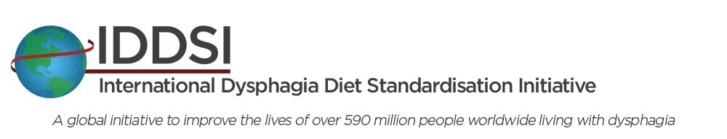
NOTES:
- Changes will be phased in, with liquid diets in the Spring/Summer of 2019, followed by food texture diets in 2020.

- There is a range of thicknesses within each category. The products in some categories may be slightly thinner than current products.

- During transition, both new and current terms will be used for ease of communication. (Eg. Mildly/Nectar Thick)

Everyone in the kitchen needs to understand these new diets.

These diets will be implemented ______________

Our current diets will be changed to these new diets (implementation date or time frame).
Our current diets will be changed to these new diets (implementation date or time frame).
Our current diets will be changed to these new diets (implementation date or time frame).

Poster 3: Product Label Changes

New Dual Labels | Old Labels:
Mildly Thick (2) /Nectar | Nectar Consistency
Moderately Thick (3)/Honey | Honey Consistency
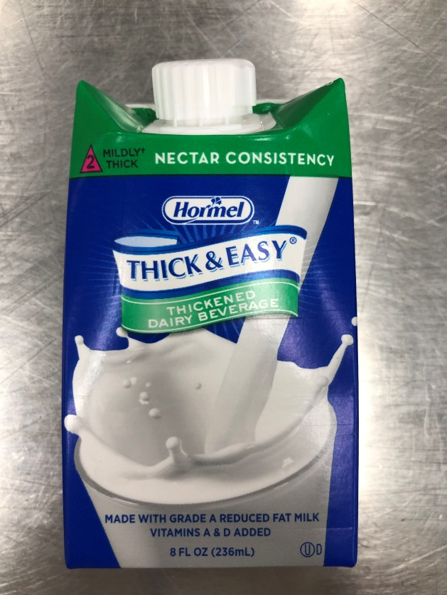  Example: Hormel Thickened Dairy (dual) | 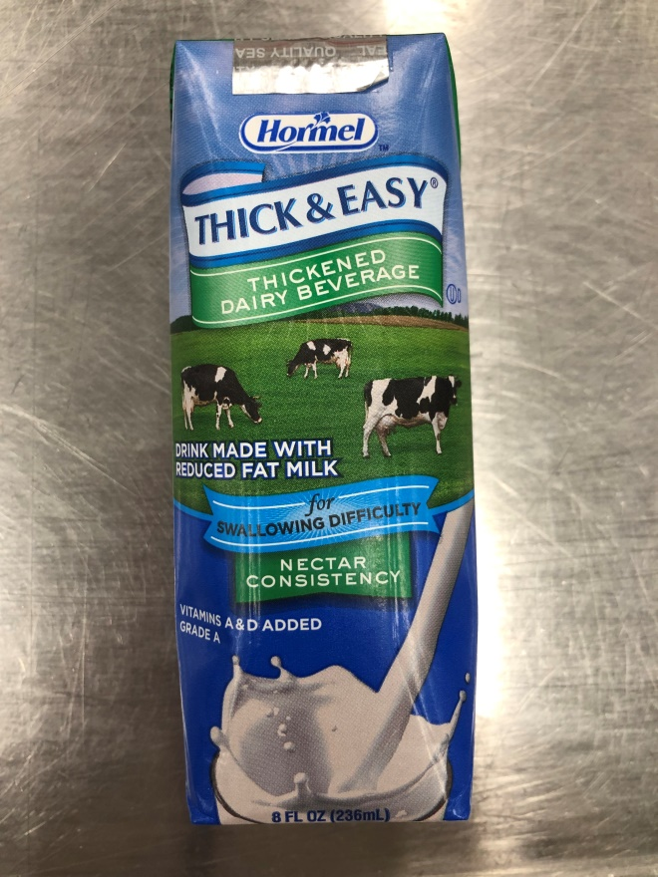  Example: Hormel Thickened Dairy (old)

Poster 4: Tray Ticket Changes

New Diet Name & IDDSI Abbreviation | New Dual Name & Abbreviation | Old Diet Name & Abbreviation
Mildly Thick =  MT2 | Mildly/Nectar Thick (2) = MT2/THKNEC | Nectar Thick =  THKNEC
Moderately Thick = MO3 | Moderately/Honey Thick (3) = MO3/THKHON | Honey Thick =  TKHHON
 | Example: Tray Ticket (dual)  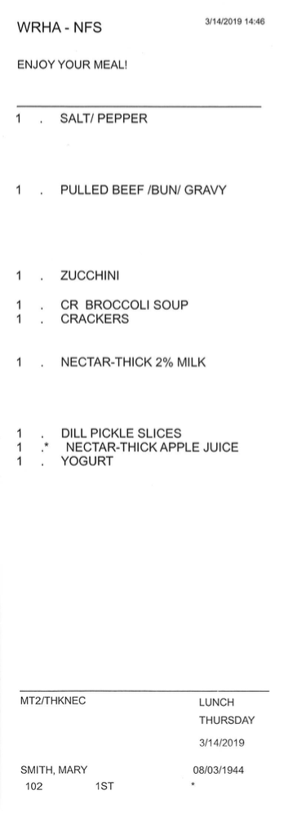  MILDLY-THICK-2%MILK | Example: Tray Ticket (old)  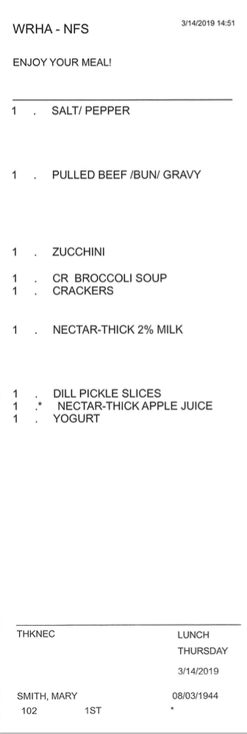
Note: These are proposed edits to the tray tickets, that are yet to be finalized.

