Designed by Colleen Rempel
Dietetic Intern, WRHA
Implementation Package
For Phase 1 IDDSI Transition across the Winnipeg Regional Health Authority
International Dysphagia Diet Standardisation Initiative (IDDSI)
Phase 1 - Implementation Plan

Table of Contents
IDDSI Implementation Plan – Phase 1 3
Background & Purpose of IDDSI: 3
IDDSI Framework, including WRHA Implementation Phases: 3
Goal: 3
Facilities Targeted: 3
OVERALL TIMELINE – PHASE 1 4
EDUCATION 5
FOOD SERVICE 6
CLINICAL SERVICES 8
APPENDIX 9
APPENDIX A – Education Plan 10
Education Plan Outline: 10
Knowledge Assessment Quiz: 11
APPENDIX B – Education Resources 12
Five Minute Huddle: Script 12
Poster 1: IDDSI Framework – WRHA Implementation Phases 13
Poster 2: New/Current IDDSI Diet Terminology 14
Poster 3: Product Label Changes 15
Poster 4: Tray Ticket Changes 16
APPENDIX C – Continuous Quality Improvement (CQI) 17
WRHA IDDSI CQI Audit Completion Guidelines 17
IDDSI Liquids (0-3) Testing Audit Form 19
Flow Test Procedure: Hot Soups 20

IDDSI Implementation Plan – Phase 1

Background & Purpose of IDDSI:

The use of standardized diet texture and liquid-modification classifications is critical in ensuring consistency and minimizing errors surrounding diet textures. Standardized terminology and definitions allow for consistent communication among health professionals, care providers, clients, family, researchers and industry partners.

WRHA Nutrition & Food Services – Feeding & Swallowing Expert Review Group has completed a review of the literature, current practice and has identified International Dysphagia Diet Standardisation Initiative (IDDSI) as best practice.

IDDSI was formed by global experts in the area of dysphagia and has a principle goal of enhancing safe care of people with trouble chewing and swallowing across all sites, ages and cultures. When we use the same diet names and descriptions, we can be sure that we know what foods fit on each diet and provide safe care when a person comes to our site. These guidelines are being implemented across Manitoba (and Canada), and allows us to communicate consistent diet information when individuals are transferred, and reduces the need for re-education when staff move from one site to another.

IDDSI Framework, including WRHA Implementation Phases:
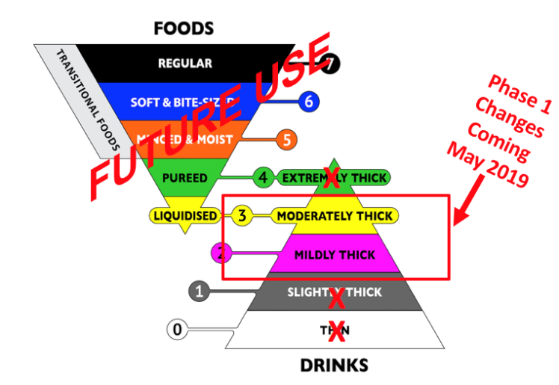
Photo Credit: The International Dysphagia Diet Standardisation Initiative 2016 @https://iddsi.org/framework/

Goal:
Changes in diets will be phased in, first with thick liquid diets, then with diet textures.
Phase 1 Implementation (thick liquid diets) – May 2019
Phase 2 Implementation (diet textures) – Proposed for 2020.
During transition, both new and current terms will be used for ease of communication (Eg. Mildly/Nectar Thick)

Facilities Targeted: All WRHA Facilities
Note that this list of activities is intended to meet the needs of a variety of sites. Your site may not use some of the tools listed and therefore are not applicable in your situation. While this list is intended to be comprehensive, it will be updated as missing items are identified.

OVERALL TIMELINE – PHASE 1
Date | Work Completed to Date
Feb 2015 | Feeding & Swallowing Expert Review Group formed
May 2015 | Feeding & Swallowing Expert Review Group first draft of Executive Summary and recommendations (IDDSI) communicated to Regional Clinical Nutrition Managers
Sept 2017 | Development of Diet Criteria
Sept 2017 | Feeding & Swallowing Executive Summary sent out for stakeholder review
Nov 2018 | Communication of plans for implementation of IDDSI diets to Directors of Care
Jan 2019 | Education session provided to PCH food service staff (IDDSI Email Distribution Group) developed by Feeding & Swallowing Expert Review Group LTC Representatives
Jan 2019 | Resources sent to IDDSI Distribution Group to begin review and determination of resources pertinent to site food service staff. PowerPoint, posters
Jan 2019 | To begin transition process with identification of food service documents requiring updating (see detailed list under Food Service Implementation)
Feb 2019 | PowerPoint with Voice Over planning
Date | Upcoming Action Steps
Mar 2019 | Memo to announce implementation date starting May 2019 to:  - Clinical Programs  - Medical Advisory  - Nursing Leadership  - Allied Health (including RD, SLP, OT etc.)
Apr 2019 | Education of Phase 1 IDDSI to Staff (See Education Action Items)
Apr 2019 | Establish updated CQI protocols (See Food Service Action Items)
Apr 2019 | Identification and update of resources used within the site overall
Apr 2019 | Update of identified food service resources
Apr 2019 | Update all written tools and resources with dual terminology. (Exception: SLP Assessment Form will be updated with new terminology Fall 2019)
May 2019 | Transition to using IDDSI Thick Liquid Diet Terminology in all WRHA sites.
May to July 2019 | Update diet orders/care plans/patient files with IDDSI Phase 1 thick liquid diet terminology (See Clinical Services Action Items)
July 2019 | All client records updated to dual terminology at all WRHA sites
Fall 2019 | Update SLP Assessment Forms to WRHA IDDSI Phase 1 terminology

EDUCATION
Date | Action Item | Who is Responsible? | Done?
April 2019 | Develop Education Plan (See Appendix A) | Site Champion(s)
 | Provide Education (based on site needs)
 | Ensure all staff impacted by IDDSI Phase 1 transition have participated in education
 | Test Staff Knowledge with Post-Education Quiz (See Appendix A)
Learning Objectives: All Staff should be able to:
- Identify new diet terms and abbreviations
- Use dual terms in communication with other staff
Learning Objectives: Food Service/Cooks:
- Perform IDDSI Testing Procedure following CQI Audit Guidelines (See Appendix C)
- Prepare foods and thick liquids of the appropriate viscosity

FOOD SERVICE
Date | Action Item | Who is Responsible? | Done?
Food Service Management
April 2019 | Update Staff Orientation/Training Tools, including:  - Resources for employees providing thickened liquids (Eg. Posters with recipe directions up on the wards)  - Other: __________________________________
Update current CQI audits with new terminology (as required):
- Menu audit
- Point of Service Audit
- Plate Waste Audit
- Hydration Program Audit
Implement CQI for IDDSI:
- Standardized recipes with IDDSI guidelines and testing methods as required (Eg. Soup)
- Implementation of IDDSI testing procedures and recording guidelines. (See Appendix C)
Order enough BD Syringes to complete testing.
(Please see www.iddsi.org for specifications on syringe requirements)
 | Test all thickened liquids and soups made in house to determine which thick liquid level it is compliant to. (See WRHA IDDSI CQI Audit Guidelines in Appendix C) | Cooks
 | Update Communication Tools with the units
 | Update Menu and/or Menu Database
 | Update Recipes for thickened products
Update Production Forms/Tools (as required):
- Tallies
- Diet Lists
- Other:___________
Update Ordering Forms/Tools (as required):
- Inventory Sheets
- Ordering Frequency Charts
- Other: ___________________

Update Service Forms/Tools (as required):
- Seating Plan
- Feeding Plan
- Tray Tickets
- Diet Kardex
- Other: _____________

Meals on Wheels (MOW)
Update to include dual terminology:
- Client files
- Client Education Resources
- MOW website
Electronic Clinical Systems
 | RDF CBORD
April 2019 | Update the following with dual terminology:  - Diet Compendium  - Diet Criteria  - Diet Names/Abbreviations on Tray Tickets  - CBORD Card Files
 | PCH Electronic Systems
April 2019 | Update Computer System with dual terminology
 | Electronic Patient Records
April 2019 | Contact Clinical Informatics Specialist to update EPR and EDIS (2-3 week timeframe) | Jean Helps
April 2019 | Update Accuro

CLINICAL SERVICES
Date | Action Item | Who is responsible? | Done?
INTER-PROFESSIONAL TEAM
(MD, RN, RD, SLP, OT)
May – July 2019 | Update all documentation that includes thick liquid terminology to dual terminology (IDDSI/Current), as needed:  - Diet Orders  - Care Plans/Kardex  - Activities of Daily Living (ADL) Sheets  - Working patient/resident file  - Referral forms  - Resources/Posters for staff preparing thick liquids on the wards  - Patient/Family handouts and educational materials
Registered Dietitians
May 2019 | Begin using dual terminology in all communications.
 | Community Services: Home Care, Primary Care, Day Hospital, PRIME
 | Update Delegated Task Program Staff Orientation and Training Resources (Home Care) | Roberta McPeak
Speech Language Pathologists
May 2019 | Begin using dual terminology in all communications.
 | Update SLP patient bedside diet order signage.
Fall 2019 | Update Assessment Forms to Include New Diet Names

APPENDIX

APPENDIX A – Education Plan

Education Plan Outline:

Important Points:
• The memo informing sites of the change in fluid diets may be used as a communication/education tool.
• Education tools that may be used on an ongoing basis include: dual labelled products, dual term diet orders, transition posters, and five minute huddle resource.
• The education may be presented by any an Education Champion such as Clinical Dietitian, Speech Language Pathologist, Unit Manager, Clinical Resource Nurse or Educator.

Learning Objectives: identify required learning of each stakeholder group

- Unit Staff (nurse, unit clerk, HCA): recognize and use new thick liquid diet terminology
- Food Service:
- Cook:
  - Prepare foods and thick liquids of the appropriate viscosity
- Food Service Supervisor and/or cook:
  - Perform testing method including documentation correctly
  - Understand the characteristics of thick fluid diets
- Diet Clerk and Diet Aide:
  - Recognize and use new thick liquid diet terminology
  - Document and provide appropriate foods/liquids as per diet order
- Inter-professional Team: recognize and use new liquid diet terminology

Develop an Education Plan:

- Identify IDDSI Education Champion(s)
- Assess the need of the facility
  - Determine English proficiency of each stakeholder group
  - Determine amount of detail required by each stakeholder group
  - Determine availability of participants
  - Determine time frame available for education, based on amount of detail required by stakeholder
- Review Education Resources and Determine Mode of Education & Delivery Method:
- 5 Minute Huddle: Script & Posters: This includes script and 4 posters. Educators need to determine which posters may be best suited to each stakeholder group.
- Thick Liquid Transition Posters: Four posters found within Five Minute Huddle may be used as stand-alone posters
- PowerPoint with Voice Over
- PowerPoint template, modified for site/department use
- Knowledge Assessment Quiz

- Review IDDSI Resources:
  - See IDDSI website: https://iddsi.org/resources/
- Logistics (dependent upon mode of education):
  - Schedule education - space, time and day, equipment
  - Identify space for posting resources
- Education provision:
  - Provide education
  - Evaluate knowledge transfer (Knowledge Assessment Quiz)
  - Address knowledge gaps

Knowledge Assessment Quiz:

You may use this quiz to test the knowledge of staff that have received education regarding the Phase 1 IDDSI Transition to new thick liquid diets.

- We are making changes to the diet names to follow IDDSI standards for what reason?
  - Patient Safety
  - Communication between sites
  - All of the above

Answer: C, All of the above

- Draw a line to match the current with the new IDDSI diet names that go together:

Nectar Thick Honey Thick
Moderately Thick Mildly Thick

Answer: Mildly – Nectar / Moderately – Honey

- In May, we will be transitioning directly to using IDDSI terminology ONLY:
  - True
  - False
Answer: False, we will be using DUAL terminology for up to 8 months.

- Choose the Correct Abbreviations for the new thick liquid IDDSI terminology:
  - Moderately Thick = MODTHK / Mildly Thick = MILDTHK
  - Moderately Thick = MO3 / Mildly Thick = MT2
  - Moderately Thick = MOD3 / Mildly Thick = MILD2

Answer: B

APPENDIX B – Education Resources

Five Minute Huddle: Script

WHAT is IDDSI?
- The WRHA (Winnipeg Regional Health Authority) Feeding & Swallowing Expert Review Group has identified and accepted the International Dysphagia Diet Standardisation Initiative (IDDSI) as best practice.
- As a result, Nutrition & Food Services is reviewing and updating our diet compendium, including diet texture and thick liquid diets.
- In 2019, we are starting with Phase 1 of ISSDI Implementation, with terminology changes to the thick liquid diets.
- In 2020, Phase 2 implementation will impact terminology and types of food texture diets.
- We will follow the IDDSI Framework, which includes new names, colours and numbers to identify the different diets. (See Poster 1). At a minimum, diet name and number will be identifiers within WRHA.

WHO does IDDSI impact?
- Across the WRHA, we are changing diet texture and thick liquid names to match international standards (IDDSI).
WHY is IDDSI important?
- This is important for PATIENT SAFETY across all ages, care settings and cultures.
- Terminology becomes consistent in all care settings, with all practitioners.
- Example: In Canada, a 88 year old patient named Eldon on the wrong diet type choked on partially chewed food and died.
- When somebody is placed on a texture or consistency modified diet, it may be for client preference, however usually these diets are required for client safety! Among other things, texture and consistency modified diets may help reduce the risk of choking, food or liquid going into the airway, ease chewing, and improve quality of life surrounding meals.

WHEN is IDDSI being Implemented?
- Transition to new terminology for diet orders and client care plans will begin May 1, 2019.
- By the end of July 2019, it is anticipated that all care plans will be updated.

HOW will IDDSI be Implemented?
- During transition, we will start using dual labels including BOTH the current and new terminology. (See Posters 2 & 4).
- Dual Terminology will be used for up to 8 months, depending on the site.
- Transition to only IDDSI terminology for thick liquid consistency is expected by the end of 2019.

ADDITIONAL NOTES:
- We have created an implementation package to help you make the transition.
- Depending on the sector and site you work at, changes needed will be different.
- Education is extremely important so that all staff are aware of the changes.

Poster 1: IDDSI Framework – WRHA Implementation Phases

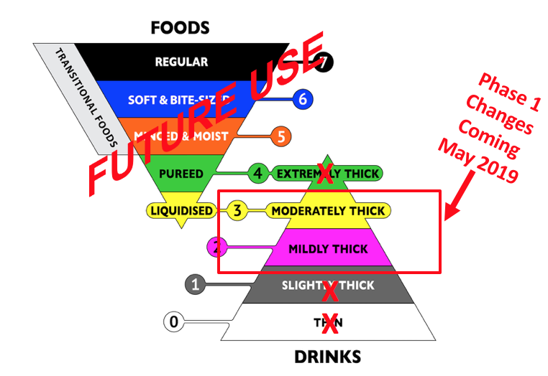
Photo Credit: The International Dysphagia Diet Standardisation Initiative 2016 @https://iddsi.org/framework/

Poster 2: New/Current IDDSI Diet Terminology
New Thick Liquid Diets

IDDSI (International Dysphagia Diet Standardization Initiative)

PURPOSE OF CHANGE:

- To enhance safe care of individuals with trouble chewing and swallowing.

- Consistent use of diet names and descriptions between sites and programs.

Everyone in the kitchen needs to understand these new diets.

These diets will be implemented ______________

Upcoming Changes in Thick Liquids:
New Diet Terms | Current Diet Terms
MILDLY THICK (2) | Nectar Thick
MODERATELY THICK (3) | Honey Thick

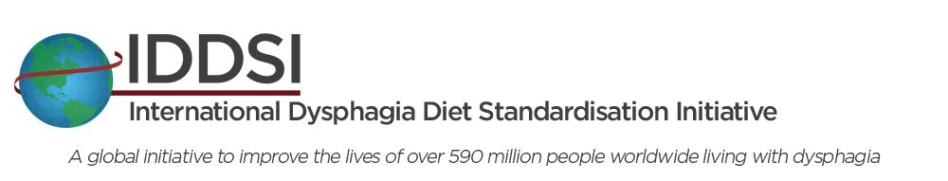
NOTES:
- Changes will be phased in, with liquid diets in the Spring/Summer of 2019, followed by food texture diets in 2020.

- There is a range of thicknesses within each category. The products in some categories may be slightly thinner than current products.

- During transition, both new and current terms will be used for ease of communication. (Eg. Mildly/Nectar Thick)

Everyone in the kitchen needs to understand these new diets.

These diets will be implemented ______________

Our current diets will be changed to these new diets (implementation date or time frame).
Our current diets will be changed to these new diets (implementation date or time frame).
Our current diets will be changed to these new diets (implementation date or time frame).

Poster 3: Product Label Changes

New Dual Labels | Old Labels:
Mildly Thick (2) /Nectar | Nectar Consistency
Moderately Thick (3)/Honey | Honey Consistency
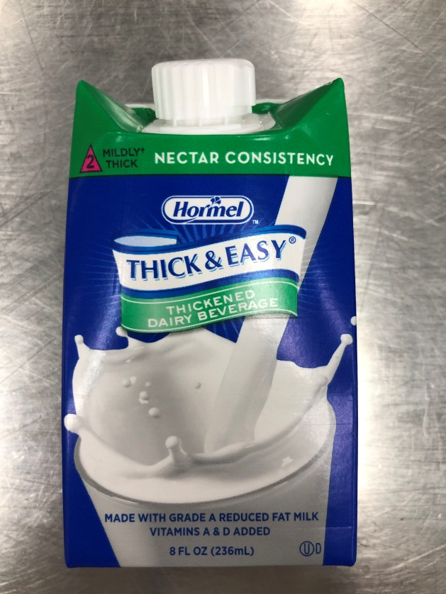  Example: Hormel Thickened Dairy (dual) | 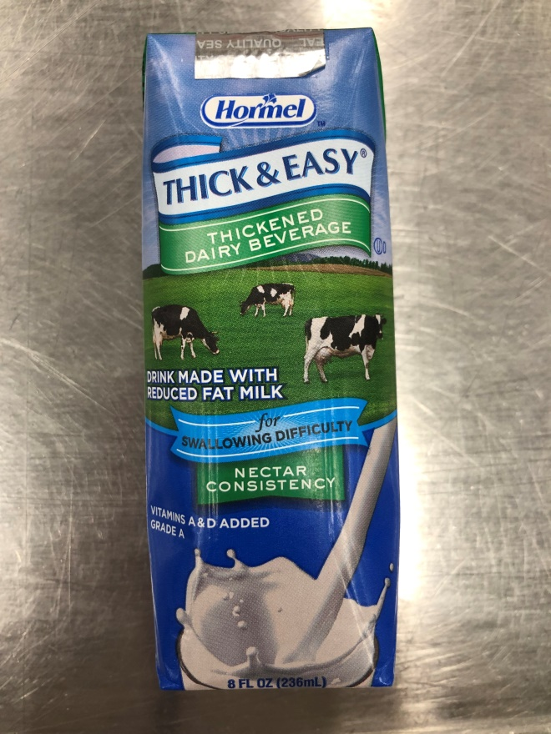  Example: Hormel Thickened Dairy (old)

Poster 4: Tray Ticket Changes

New Diet Name & IDDSI Abbreviation | New Dual Name & Abbreviation | Old Diet Name & Abbreviation
Mildly Thick =  MT2 | Mildly/Nectar Thick (2) = MT2/THKNEC | Nectar Thick =  THKNEC
Moderately Thick = MO3 | Moderately/Honey Thick (3) = MO3/THKHON | Honey Thick =  TKHHON
 | Example: Tray Ticket (dual)  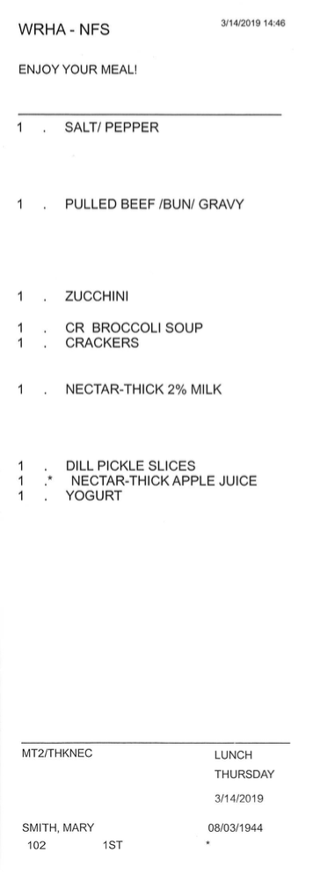  MILDLY-THICK-2%MILK | Example: Tray Ticket (old)  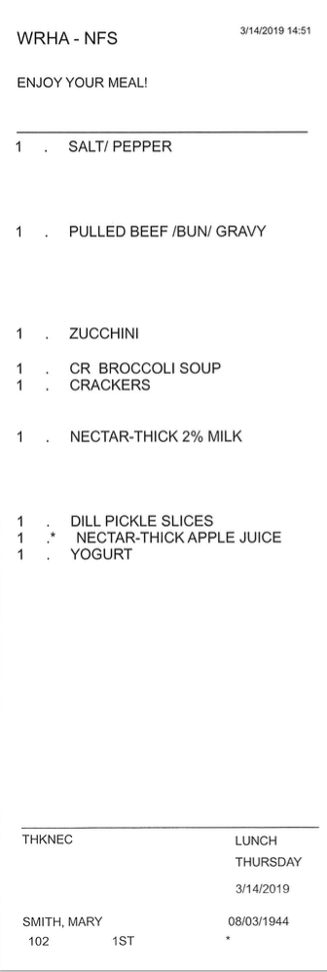
Note: These are proposed edits to the tray tickets, that are yet to be finalized.

APPENDIX C – Continuous Quality Improvement (CQI)

WRHA IDDSI CQI Audit Completion Guidelines
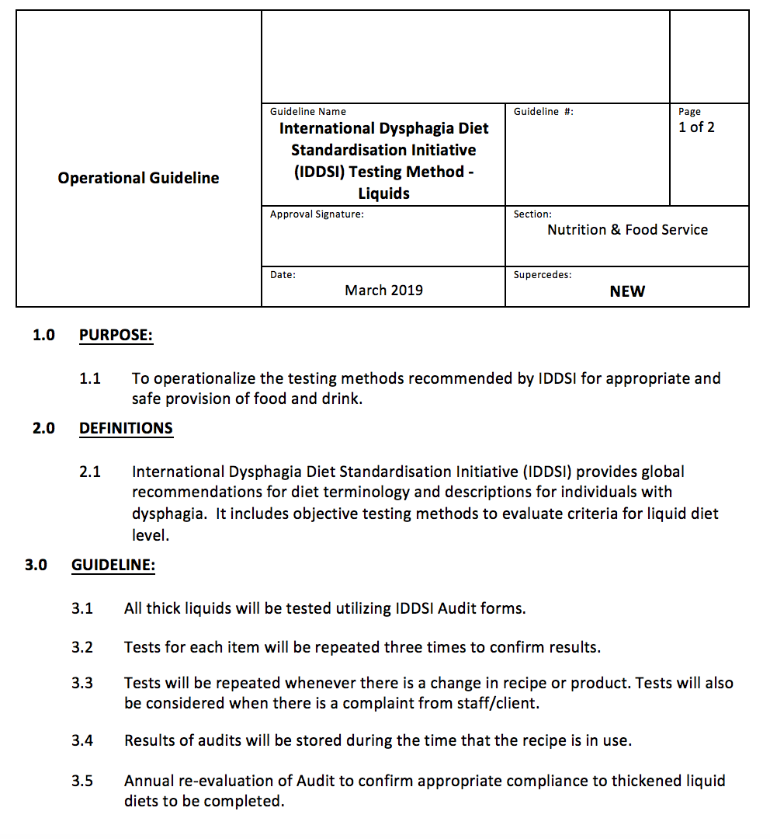

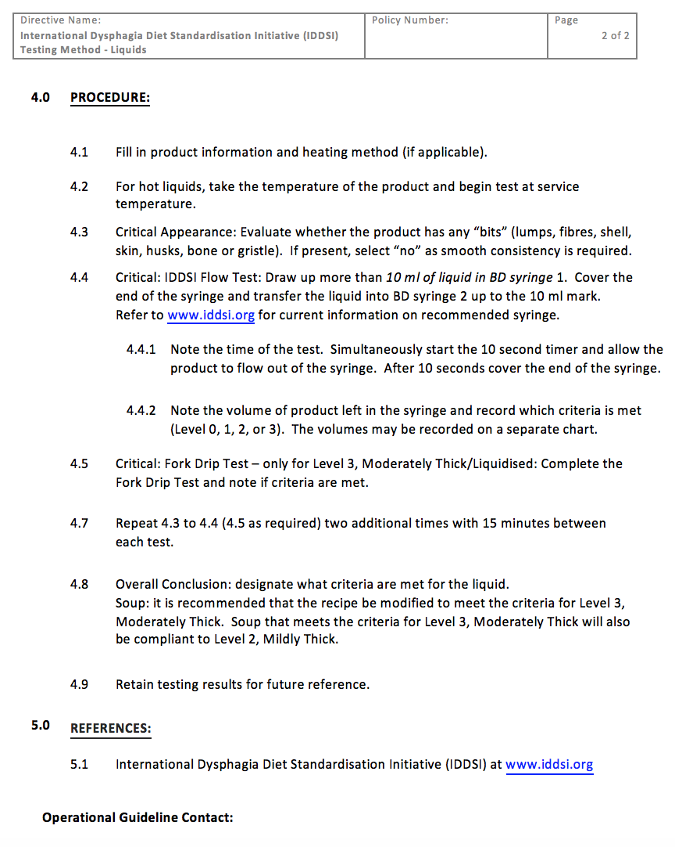

IDDSI Liquids (0-3) Testing Audit Form
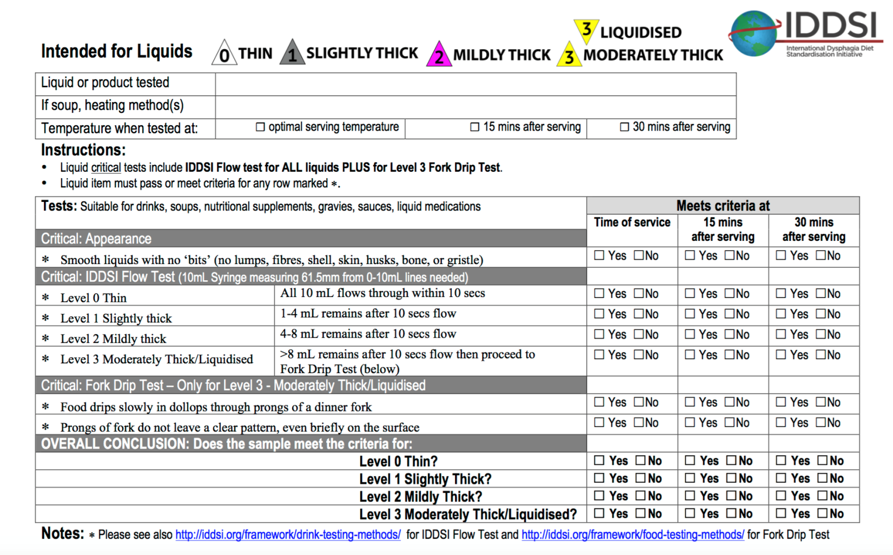

- Downloadable file can be found at: https://iddsi.org/wp-content/uploads/2018/01/Liquids_L0_L1_L2_L3_18-January-2018.pdf

Flow Test Procedure: Hot Soups

Size of one portion: 10ml+

Quantity:  15ml  2  1 | Ingredients/Supplies  Soup to be tested  BD Syringes  Pair Silicone Gloves

Steps:
- Ensure soup temperature is appropriate for service (Eg. Minimum 70°C)
- With care, draw up greater than 10ml into a BD syringe.
- Cover the tip of the syringe with a silicone gloved hand.
- Carefully, syringe 10 ml of soup into the clean test syringe, covering the tip with a silicone gloved hand.
- Simultaneously, start 10 second timer & remove finger to allow liquid to flow out of the syringe.
- At the end of 10 seconds, cover tip of syringe.
- Measure how much fluid is remaining.
- Determine thick liquid category based on IDDSI guidelines.
**Visual for steps 3-8 is below:
