Insert Date

Dear Parent/Guardian,

Re: Community Notification Letter—Insert Name of Child Care Centre

Manitoba public health officials have advised of at least one confirmed case of COVID-19 in the child care centre on Insert Date in Insert Child Care Centre/Cohort or other location (as applicable) when the individual(s) may have been infectious. The child care centre is working closely with public health officials and is following their recommendations. Close contacts have been identified and are advised to self-isolate.

If you have not been contacted by the child care centre stating your child is a potential close contact and a public health official has not contacted you, your child has not been identified as being exposed to COVID-19 from this/these case(s). If your child has not been identified as a close contact, public health officials still recommend that you closely monitor your child for symptoms of COVID-19.

If your child develops a new onset or worsening of any one symptom listed in Column A or any two or more symptoms listed in Column B (see table below), even if they are mild, immediately isolate them from others.

It is recommended your child get tested for COVID-19 as soon as symptoms appear. You may go directly to the nearest COVID-19 testing location during their open hours. For the testing site nearest you, please visit https://manitoba.ca/covid19/testing/index.html, or call Health Links-Info Santé at 204-788-8200 or toll-free at 1-888-315-9257.

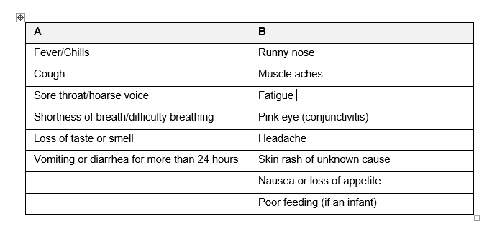

Individuals with symptoms outlined in Columns A and B, who choose not to be tested, must isolate for a minimum of 10 days following the start of symptoms. Isolation can be stopped at day 10 if the individual has been symptom-free for 24 hours. In the case of symptomatic individuals who choose not to be tested, all household members must isolate along with the symptomatic person for the 10 days.

Please note the following:
- Public health officials strongly encourage testing so it can be determined whether COVID-19 transmission has occurred within the child care centre.
- The child care centre is not permitted to release the name(s) or any identifying information about the confirmed case(s) of COVID-19 to any member of the child care centre, community, or media.
- As variants of concern (VOC) are becoming the dominant strain of the virus in Manitoba, to reduce the risk of transmission, changes have been made to how we manage all COVID-19 cases and contacts. There will no longer be separate notification or different recommendations if the case is a VOC. For more information about VOCs, please visit www.gov.mb.ca/covid19/fundamentals/variants.html.

For more public health information about COVID-19, please visit
https://manitoba.ca/covid19/updates/resources.html

Sincerely,

Office of the Chief Provincial Public Health Officer
Health and Seniors Care

