Date:
Population and Public Health

Dear ___________________________
I am sorry I’ve been unable to reach you by phone. You have tested positive for COVID-19 and require isolation. Information on how to isolate is enclosed and linked by the QR codes below.
Please call me at _______________ within 24 hours so we can discuss further. My office hours are ___________________. If you reach my voicemail, please leave your full name and a number I can reach you at. If you are calling during the evening or over the weekend, I will return your call as soon as I am back in the office.

For information on how to isolate after hours or on weekends, you may call Health Links/Info Santé at 204 788-8200, or toll free 1-888-315-9257.

Please begin to think about who you may have been in contact with, starting from 2 days before your symptoms began (or 2 days before you were tested) until you began to isolate and make a list so we can review when I talk to you.
Thank you for your attention to this important health matter.
Sincerely,

[full name, RN]
Public Health Nurse
Phone Number:

Information sur l’Isolement (Français)  https://www.gov.mb.ca/asset_library/en/covid/factsheet-isolation-selfmonitoring-recoveringhome.fr.pdf | Isolation Information  http://www.manitoba.ca/asset_library/en/coronavirus/factsheet-isolation-selfmonitoring-recoveringhome.pdf | Other Languages  https://www.gov.mb.ca/covid19/updates/resources.html#collapse2
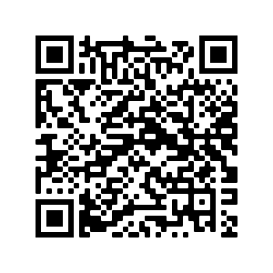 | 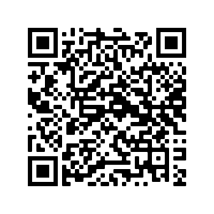 | 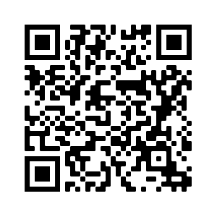
If you have a QR reader on your smartphone, open your camera and hold over to scan the QR code. A link to https://www.gov.mb.ca/covid19/updates/resources.html will appear.

