INSTRUCTION LETTER FOR PEOPLE WHO HAVE TESTED POSITIVE FOR COVID-19

Date: Click or tap to enter a date.
Dear: Click or tap here to enter text.
You are receiving this letter as Public Health has not been able to reach you by phone. You have tested positive for COVID-19. This letter provides information about how to self-isolate, care for yourself, and inform your close contacts.
More information for you and your close contacts is provided in the Government of Manitoba webpage links at the end of this letter.
SELF-ISOLATION: You are required to self-isolate for at least a 10 day period, beginning at the time you began to experience symptoms. If you continue to experience a fever after that 10 day period or are not improving, you are required to continue self-isolating; though lingering symptoms such as cough or loss of taste or smell can persist beyond the isolation period, these particular symptoms are not reasons for continuing isolation.
If you have no symptoms, self-isolate for the 10 days after your test date.
Self-isolation means:
- Stay home unless you need emergency medical care.
- Do not leave your home for non-emergency reasons, such as work, school, groceries, pharmacies, or non-urgent medical care. Ask family and friends to help with these activities while you are self-isolating.
- Use a separate bathroom if you have one.
- Wash your hands and clean surfaces you touch often (lights, knobs, taps, etc.).
- Stay in a separate room from other people in your home, including when you are preparing or eating food.
- If you must be in the same room/area with other people:
  - Stay at least 2 meters (6 feet) apart, both indoors and outdoors.
  - Everyone should wear a mask.
CARING FOR YOURSELF: If you have severe symptoms, such as difficulty breathing, please call 911 or attend an emergency department. For health issues that are not urgent, you may call your regular health care provider, or Health Links/Info Santé at 204 788-8200, or toll free 1-888-315-9257.
- General Supports: Manitoba 211 provides information about a range of social and mental health supports that may be helpful during this time. Call 2-1-1 or visit mb.211.ca
- Treatment: You may be eligible for monoclonal antibody treatment to reduce your risk of severe disease if our symptoms began less than 7 days ago, and you are:
  - Immunocompromised; OR
  - Not fully vaccinated and over 18 years of age and at high risk of developing severe disease because of your age or underlying health issues.
Please contact Health Links/Info Santé at 204 788-8200, or toll free 1-888-315-9257, to find out if this treatment is right for you. For more information: https://manitoba.ca/covid19/treatment/index.html
TELL YOUR HOUSEHOLD MEMBERS AND OTHER CLOSE CONTACTS RIGHT AWAY
Close contacts include your household members AND anyone you have been within 2 meters of for 10 minutes or more during your infectious period. Your infectious period starts 2 days before your symptoms started, or 2 days before your test date if you have no symptoms, and ends at the end of your isolation period. See links on the next page for information about notifying your close contacts.
Generally, contacts should self-isolate for 10 days from their last contact with you. Those household contacts that you are unable to isolate away from should also self-isolate while you are isolating, and for 10 days after your self-isolation period ends, unless they fall under an exception. Close contacts should self-monitor for symptoms for an additional 4 days after isolation.
Close contacts do not need to self-isolate (are exempt) if they:
- Are fully immunized (i.e. it has been at least 2 weeks since their last dose of the vaccine series at the time of the exposure) OR recently infected with COVID-19 (i.e. within the previous 6 months); AND
- They do not have a medical condition (e.g. immunocompromised) that would impact vaccine effectiveness; AND
- They have no symptoms.
However, contacts who are exempt from isolation should watch themselves for symptoms for 14 days. Anyone who experiences symptoms should isolate right away, and get tested. Fully immunized contacts are recommended to be tested between 5 to 7 days after their last exposure.
Note that some high-risk workplaces may require contacts to isolate even if they are fully vaccinated. Contacts should notify their employers.
All other close contacts must:
- Self-isolate for 10 days since their last contact with you; and
- Get tested right away if they have symptoms. If they have no symptoms, they should get tested 7 days after their last contact with you.
Public health will follow up with high-risk workplaces and settings, such as schools/daycares, health and community care facilities, shelters and congregate living places. If you were in high-risk setting during your infectious period, please inform the facility and your local public health office as soon as possible.
Thank you for your attention to this important health matter. If you have further questions or concerns you may contact your local public health office at Click or tap here to enter text. See https://www.gov.mb.ca/health/publichealth/offices.html
Yours in health,
Manitoba Population and Public Health
If you have a QR reader on your smartphone, open your camera and hold over to scan the QR code. A link to https://www.gov.mb.ca/covid19/updates/resources.html will appear.
INFORMATION FOR PEOPLE WHO HAVE SYMPTOMS OR TESTED POSITIVE FOR COVID-19

Information sur l’Isolement (Français)  https://www.gov.mb.ca/asset_library/en/covid/factsheet-isolation-selfmonitoring-recoveringhome.fr.pdf | Isolation Information  http://www.manitoba.ca/asset_library/en/coronavirus/factsheet-isolation-selfmonitoring-recoveringhome.pdf | Treatment for COVID-19  https://manitoba.ca/covid19/treatment/index.html
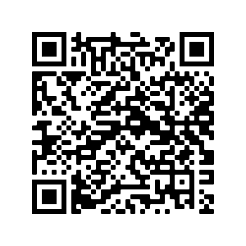 | 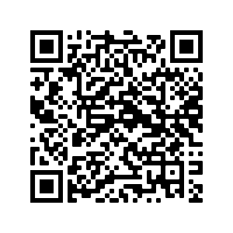 | 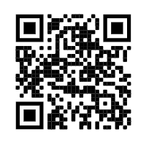
INFORMATION ON HOW TO NOTIFY YOUR CLOSE CONTACTS
https://manitoba.ca/covid19/testing/monitoring/index.html
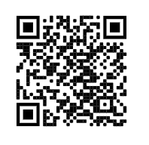
SELF-ISOLATION INFORMATION FOR CLOSE CONTACTS

Information de l’Auto-Isolement (Quarantaine)  https://www.gov.mb.ca/asset_library/en/covid/factsheet-isolation-selfmonitoring-returningtravellers-contacts.fr.pdf | Self-Isolation (Quarantine) Information  https://www.gov.mb.ca/asset_library/en/covid/factsheet-isolation-selfmonitoring-returningtravellers-contacts.pdf | Other Languages  https://www.gov.mb.ca/covid19/updates/resources.html#collapse2
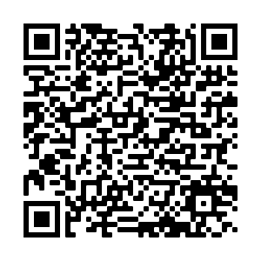 | 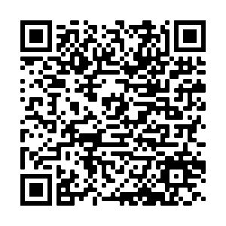 | 