iPHIS Data Entry Protocol for Cases (Confirmed, Probable and Suspect) or Contacts of COVID-19

PURPOSE: To facilitate the documentation and reporting of cases and contacts of COVID-19
Definitions
For the purpose of iPHIS documentation and surveillance, the following definitions apply in iPHIS
(*NOTE CHANGE: With the addition of “Suspect” case to the “Interim Guidance PH Measures” document, the definitions in iPHIS have changed effective, April 17, 2020, to avoid confusion with terminology.
Confirmed Case: laboratory confirmation of COVID-19 infection
Probable Case: Symptomatic contact who has not been tested, or refuses testing; manage same as a confirmed case
Suspect Case: When a contact of a case becomes symptomatic, Suspect (formerly “PUI” was used in iPHIS) will now be used as the holding place while lab results are pending; manage same as a case. If results come back positive, change status to a confirmed case; if results are negative, complete ADM then change status to “NOT A CASE”
Person Under Investigation (PUI) This is a category in iPHIS that is used as a place holder for individuals that are identified as a contact to COVID-19 but are not associated with a case in WRHA. E.g. referrals from out of region/province, people that were on flights/cruise ships with a known COVID-19 case (formerly “Suspect” was used in iPHIS); manage same as a contact; If PUI becomes symptomatic, change case status to “Suspect” and follow as a “Suspect” until test results are known. Advise CD Coordinator of status change.

PROTOCOL
Upon notification of a case of COVID-19, the following protocol is to be followed to support documentation, follow-up, and reporting to Manitoba Health.
MANITOBA HEALTH REPORTING REQUIREMENTS
- Case Investigation Form is to be faxed to CD Coordinator as follows:
  - submit to MH within 24 hours of initial notification
  - resubmit to MH if there is a change in clinical outcome
  - resubmit to MH when case is closed

  - Client Search (CD Unit Administrative Staff)
- Select Client Search.
- Perform a client search by entering the client’s PHIN. If PHIN is not available, the iPHIS user will need to enter at least two fields: Family Name, First Name, Birth Date, Gender - using the wildcard (%) where appropriate; clear the HA field to blank.

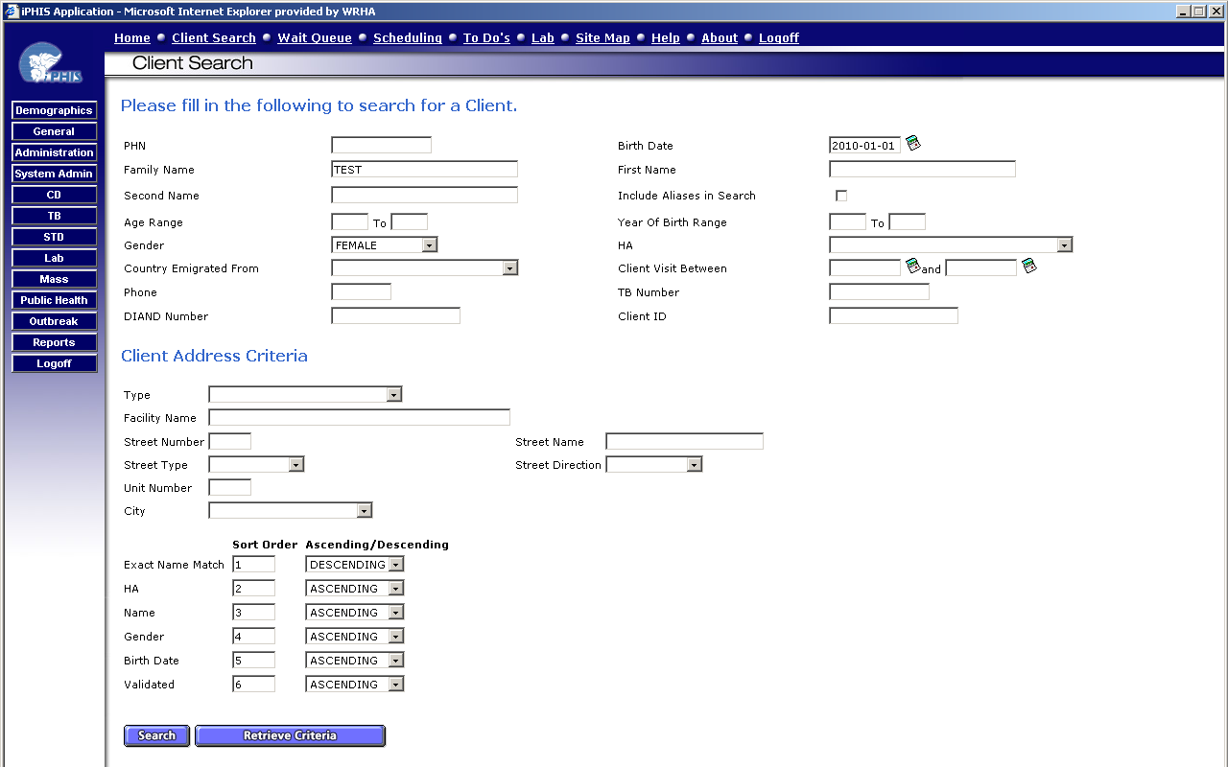

- Select Search
- If client is not in iPHIS, the iPHIS user will need to create client. Select Add Client.

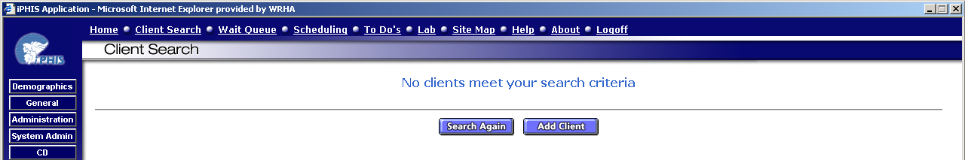

- Demographic Details – Client Info (if client has to be created) (CD Unit Administrative Staff)
  - For those clients that need to be created, enter the client’s demographic information gathered: PHIN (if provided), PHN Assigning Authority (only if PHIN provided), check off validated box, HA, Family Name, First Name, Birth Date, Gender

NB: When entering PHIN, ensure PHN Assigning Authority field is “Manitoba”; if the client is out of province, the PHIN and PHN Assigning Authority is not entered and the HA is changed to the appropriate province of birth.
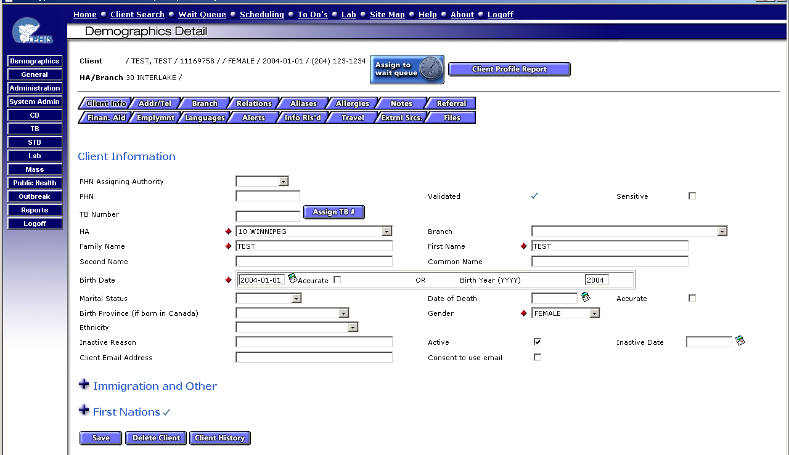

- Select Save
- For all clients, enter Addr/Tel information as required as per usual data entry procedures.

- Create a New Case (CD Unit Administrative Staff)
- Select CD (left hand side menu) → Client Cases → New Case

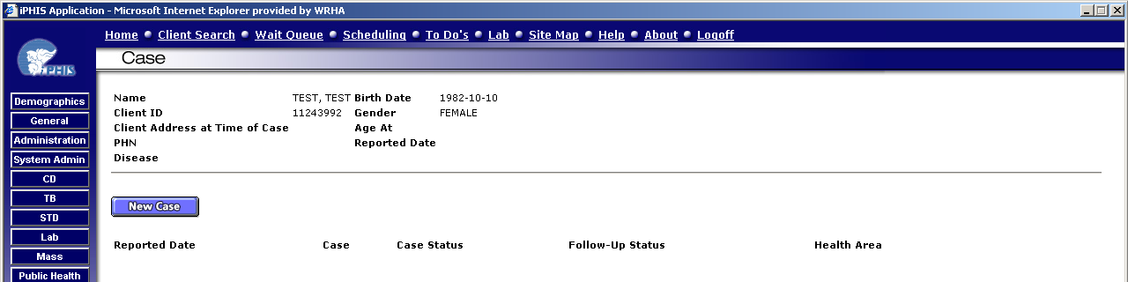

4. Entering Case Details (CD Unit Administrative Staff)
  - HA: 10 Winnipeg (when WRHA is managing case)
  - Case Reported Date: Enter the date of referral to public health
  - Follow-Up Status: Open – Awaiting more History/Information
  - Disease Code: Coronavirus
    - Etiological Agent: Coronavirus
    - Subtype: 2019-nCoV
  - Case Status: CONFIRMED/PROBABLE/SUSPECT or PUI
  - Date/Time: Current date/time
  - Client Address at Time of Case: Select current address
  - Branch Responsible: Select appropriate branch
  - Select Save

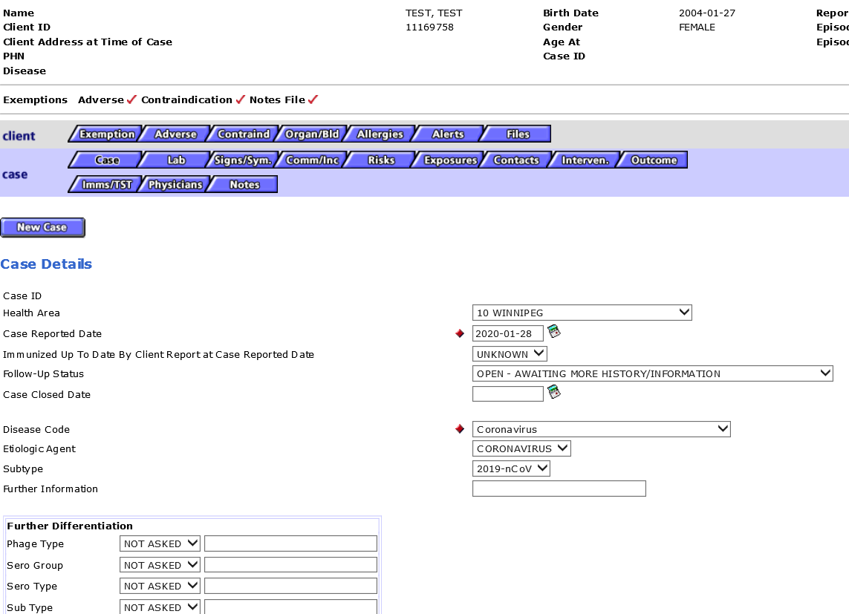
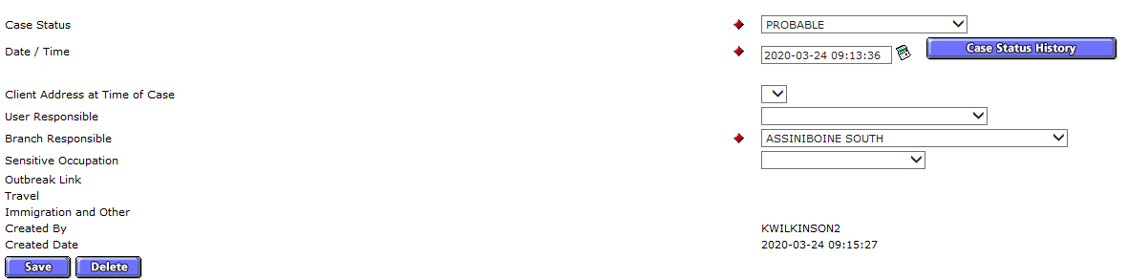

- Referral of COVID-2019 cases to PHN for follow-up (CD Unit Administrative Staff)
- Centralized COVID-19 PHN’s name to be added as “User Responsible” and to REMAIN as the responsible user, even if referred to Community Area PHN for ADM
- The COVID-19 PHN should be maintained as the primary PHN

- Sending Referrals
- For a guide, please use the link below and open iPHIS Quick Reference Guide for PHNs 2018
https://professionals.wrha.mb.ca/old/extranet/publichealth/services-info-systems.php
- Follow the tips for Sending Referrals to another PHN or the your CD Coordinator
- You will need to send the referral to the PHN assigned, your CD Coordinator, and Mia Milette.
- If you are creating the case AND assigned to the client, please make sure you send it to yourself so it will be in your To Do’s

- Creating a Chart for a New Case
- Please write the client’s name (LAST NAME, FIRST NAME) on chart
- Write the community area under 2020
- Write the PHN’s Name assigned and their CD Coordinator
- Place lab report in folder
- Place in basket labeled CD Unit and admin will pick up Monday Morning.

- Sensitive Occupation- * Required for Probable and Confirmed cases
On the case tab, enter if the case has a sensitive occupation i.e. HCW, Day Care Provider
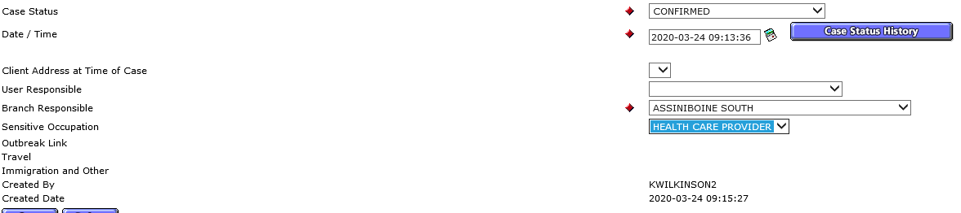

- Signs and symptoms- * Required for Probable/ Confirmed/ Suspect cases
Enter signs and symptoms in this tab
Start date is the date the symptom started and end date is date the symptom ended.
Add each symptom separately.
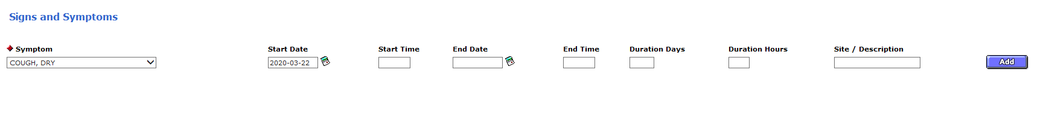
ACTIVE Daily Monitoring (ADM) to be used for PHN Follow-up and Documentation of COVID-19 Confirmed, Probable, Suspect Cases and PUIs, if necessary
- If Asymptomatic:
  - Symptom: Asymptomatic
  - Start Date: Enter the date that temperature monitoring began (date of first PHN phone call)
  - End Date: Enter the date no longer asymptomatic (ie; that symptoms began) OR date that ADM ended if remained asymptomatic throughout the monitoring time
- If remains “ASYMPTOMATIC” during the entire ADM period, there is NO need for any further entries in this tab (i.e. DO NOT select ASYMPTOMATIC multiple times each day in the Signs and Symptoms Tab. Do not record specific daily temperatures or “AFEBRILE” in the Signs and Symptoms Tab.
- Use the NOTES tab to document your daily PC to the contact, that they were afebrile if temp less than 38.0 C, and any other pertinent data, etc; sign, date and time.
- If Symptomatic:
  - Symptom: Select each individual symptom from drop-down list
  - Start Date: Enter date of onset of each symptom
  - End Date: Enter the date the symptom ended
- Site/Description: Add descriptor as required for HEADACHE [severe]
- If an “ASYMPTOMATIC” contact becomes “SYMPTOMATIC”, go into the Signs & Symptoms Tab and Update the “ASYMPTOMATIC” Symptom line by entering an End Date .
- Add in each of their Symptoms individually from the Drop Down list; enter the “Start Date” as the date of onset of the symptom. Do not enter symptoms multiple times. If symptoms resolve during the ADM period, update the symptom with an end date.
- If ALL symptoms resolve, enter the symptom “ASYMPTOMATIC” with the Start Date that they became ASYMPTOMATIC.
- Use the NOTES tab to document your daily PC to the client, that they were afebrile if temp less than 38.0 C, and any other pertinent data, etc; sign, date and time, as required.

Example of how to document:
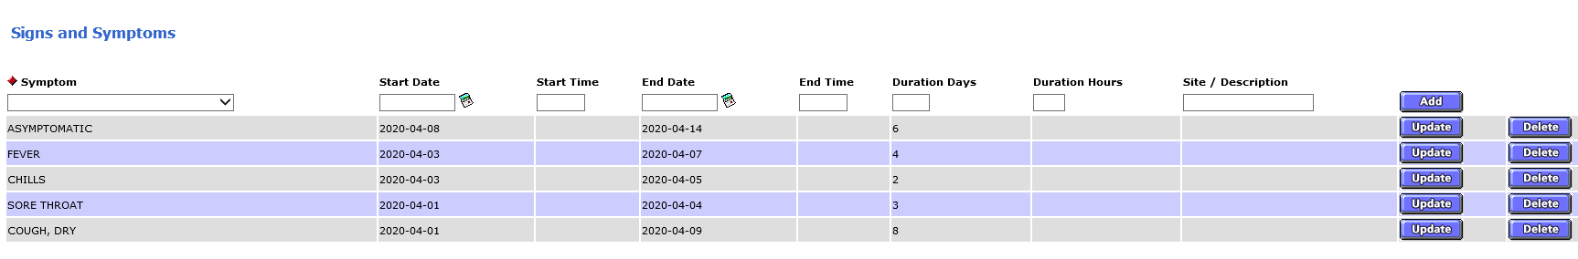

PASSIVE Temperature Monitoring to be used ONLY for PHN Follow-up and Documentation of PUIs from flight manifests/ cruise ships, where Active Daily Monitoring (ADM) is NOT indicated
- If Asymptomatic:
  - Symptom: Asymptomatic
  - Start Date: Enter the date that temperature monitoring began
  - End Date: As directed by CD Coordinator if follow-up is indicated.

- If Symptomatic:
  - Symptom: Select each individual symptom from drop-down list
  - Start Date: Enter date of onset of each symptom
  - End Date: Enter the date the symptom ended
- Site/Description: Add descriptor as required for HEADACHE [severe]

- Communicability/Incubation – * Required for Probable and Confirmed cases
The period of communicability starts from 48 hours prior to the day of the onset of the first symptom and ends 10 days later after symptom onset. (provided the case is afebrile, has improved clinically, and is not hospitalized)
The incubation period is 14 days prior to date of symptom onset (or date of specimen collection if asymptomatic). iPHIS is preset to calculate the incubation period based on the first symptom onset date when you select “system”

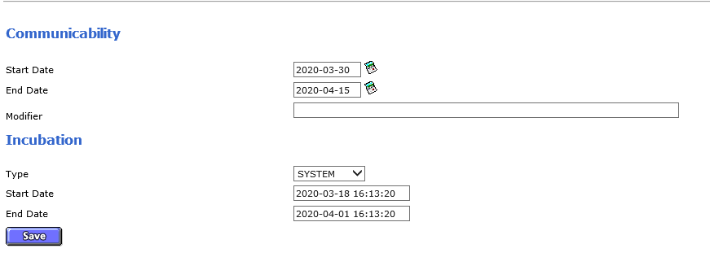

- Exposures – * Required for Probable and Confirmed cases
Enter all relevant exposures in this tab that occurred during the incubation period.
Please enter the most likely exposure first. A case may have more than one exposure.
Additional details can be entered into Comments.
PERSON-TO-PERSON – CONTACT WITH KNOWN CASE
- Select if case was a contact to a confirmed case. Enter the exposure dates, and type of contact in Case/Event Location.
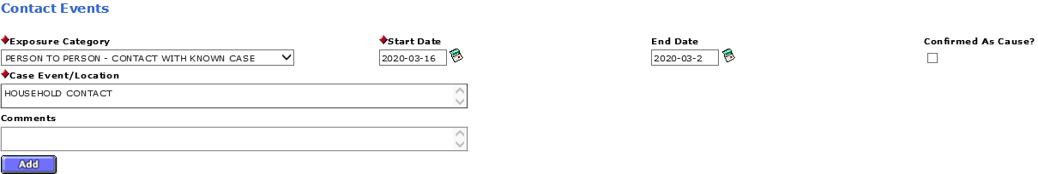
OTHER MISC – OUTBREAK ASSOCIATED
- Select if case was part of a known outbreak. A running list of outbreak event/location names will be maintained by the Epi team to ensure consistent naming conventions are used for each outbreak. Enter the exposure dates.
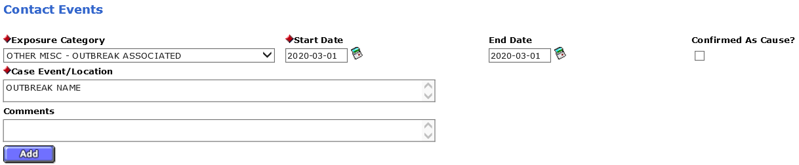
PERSON-TO-PERSON – UNKNOWN
- Select if case has no travel history and is not a contact to a confirmed case. Enter possible source in case event/location with respective dates. Add a new entry for each possible source.
- If no Case Event/Location can be identified, enter UNKNOWN and use the incubation period for the dates.
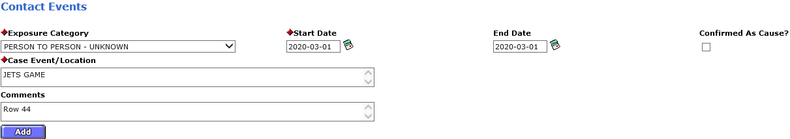
OTHER MISC – TRAVEL/LIVED IN ENDEMIC COUNTRY
- Select if there was travel during the incubation period. Enter the travel dates, and the country the case traveled to in the Case Event/Location. If the case traveled to multiple countries, please add a new entry. For cases who traveled in Canada, please enter the province name.
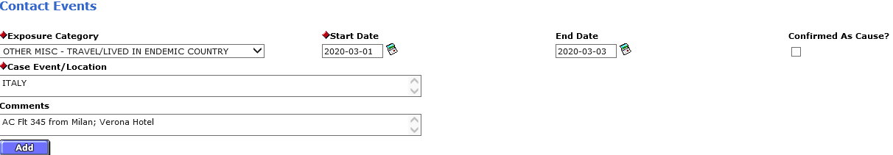
OTHER MISC – HEALTHCARE SETTING
- Select if likely exposure was in a healthcare setting. Enter the exposure dates and location in Case/Event Location.
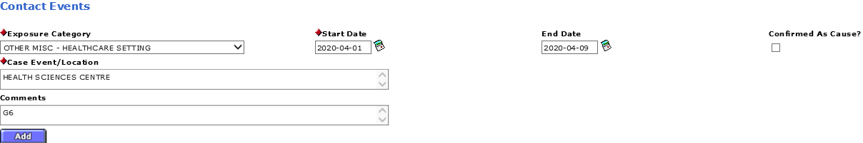

- Contacts- * Required for Probable and Confirmed cases
Enter all contacts in this tab
Either Find or Add contact; if contact is not in iPHIS, email CD admin to create and attach to case

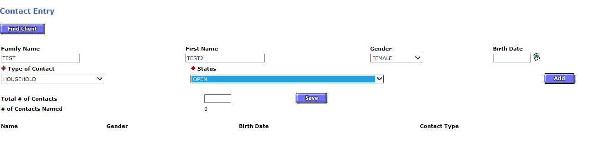

To document contact follow-up for Active Daily Monitoring (ADM):
- Select details
- Add contact phone number to “Address/Phone” field
- Contact date is the date of last exposure to the case. ADM would be at least 14 days from that date depending on symptoms of contact.
- Document follow-up in comments
- Make final notation when complete
- Ensure all entries are signed with date and time
- If a contact is named by multiple cases (ie. Household where multiple people are cases) a documentation entry should be made in each case’s contact file in order to meet documentation standards. For ease of documentation the copy and paste option is available by using Ctrl-C (copy) and Ctrl-V(paste).

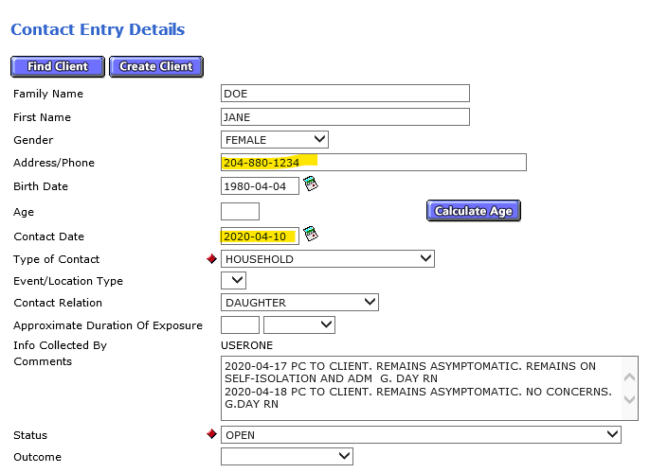
CONTACT STATUS
- If contact is out of region, change status to CLOSED-REFERRED and notify CD coordinators and admin for contact to be referred to appropriate region or province. Obtain contact demographics for referral.

- If contact is referred to the PH Contact Call Centre, change status to CLOSED-TRANSFERRED and have CD admin fax case investigation form to MHSAL

- If contact becomes symptomatic and goes for testing, documentation continues in the contact’s comment section while results are pending. If contact becomes positive, change status to CLOSED-REFERRED in the contact section and CD admin will create as a new case investigation and then CD admin will then refer out to a PHN and CD Coordinator as a new Case, where ongoing documentation will occur as a case.

- If contact remains asymptomatic and 14 day period of ADM has ended, change status to CLOSED-TREATED.

- *Note: Never use SUCCESSFUL-CLOSED or UNSUCCESSFUL CLOSED

- Interventions- for All
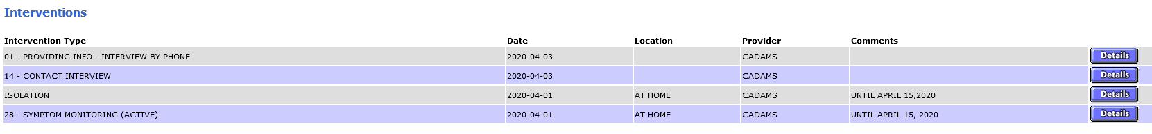
- Add appropriate interventions
- Add start date
- Add end date for ADM and Home Isolation once complete

- Outcomes – * Required for Probable and Confirmed cases
Enter outcomes in this tab
- Complete if a client is admitted to hospital, enter details ASAP and indicate treatment or ICU
- Let your CD Coordinator know ASAP if a case is hospitalized or if they decease and submit updated case form to CD Coordinator. EG:
- Under “Cause of Death”, indicate “unknown”
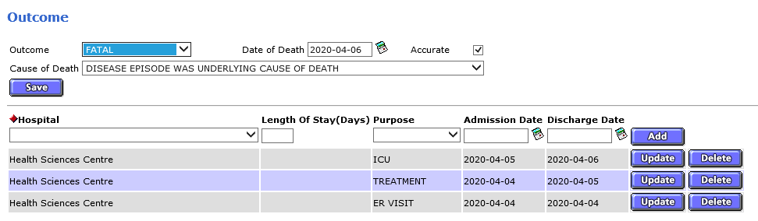

AND
Complete upon case resolution (case is recovered, recovered with residual effects, or deceased)
Case status should be entered as “Recovered” if case is asymptomatic and has completed the 10 day period from date of first symptom onset
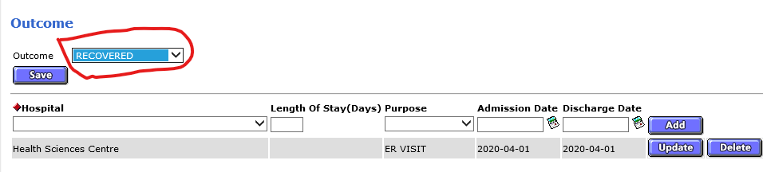
For cases that are clinically stable/recovered after the 10 days ADM (*and no longer require ongoing PH follow-up) but continue to have significant residual effects (ie:lung damage), choose “Residual effects” in the outcome tab.
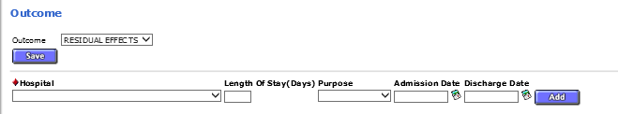
- Update Case Status as necessary
Eg. Suspect case becomes “confirmed” case or test results are negative they become “not a case”
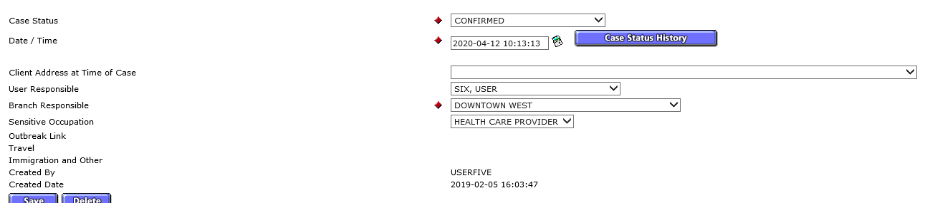

- Notes tab- for All
- Use to document all interactions related to case
- Use DARP as per WRHA PPH documentation standards
- Daily ADM interactions to be documented in notes tab
- Put in closing note when completed

